第五章 输入输出管理

知识点：

5.1I/O管理概述：
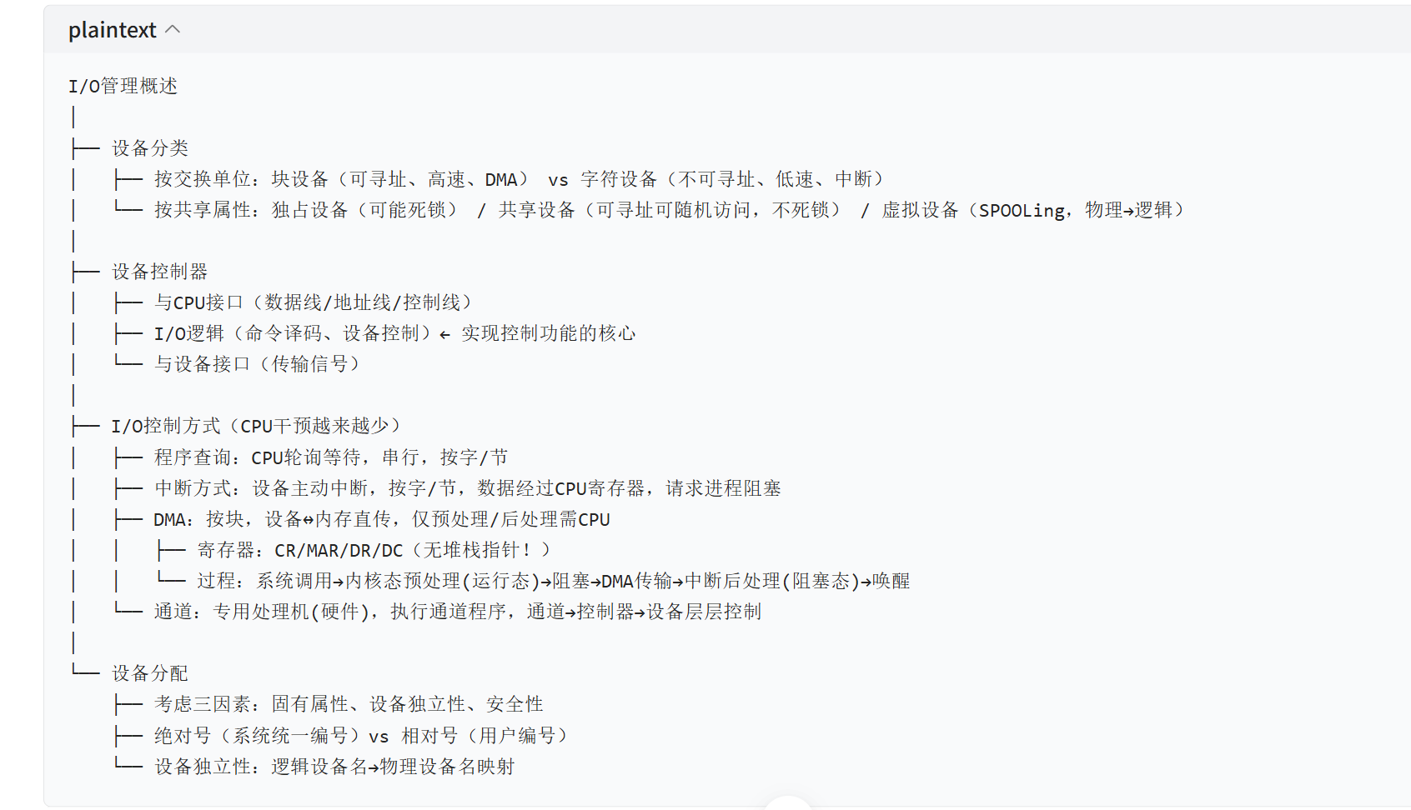
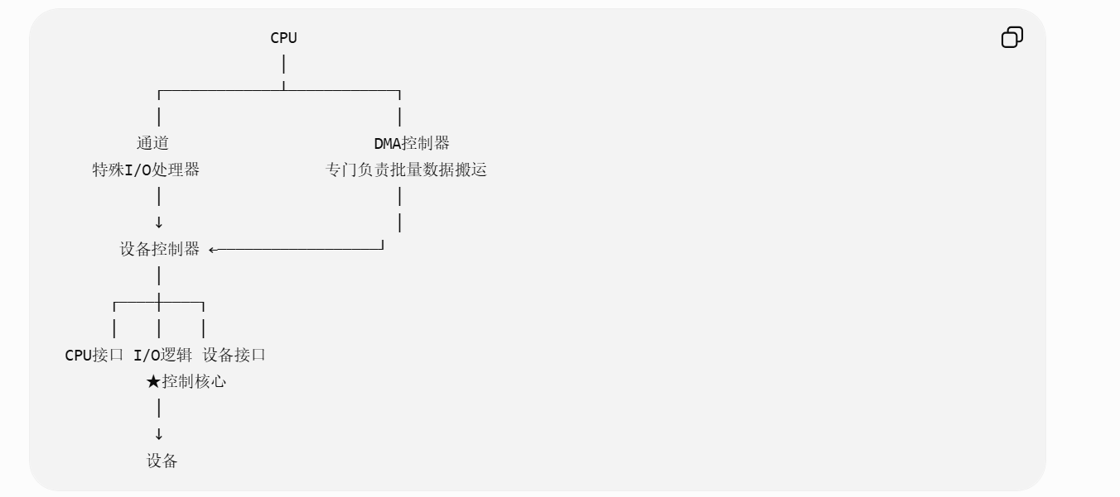
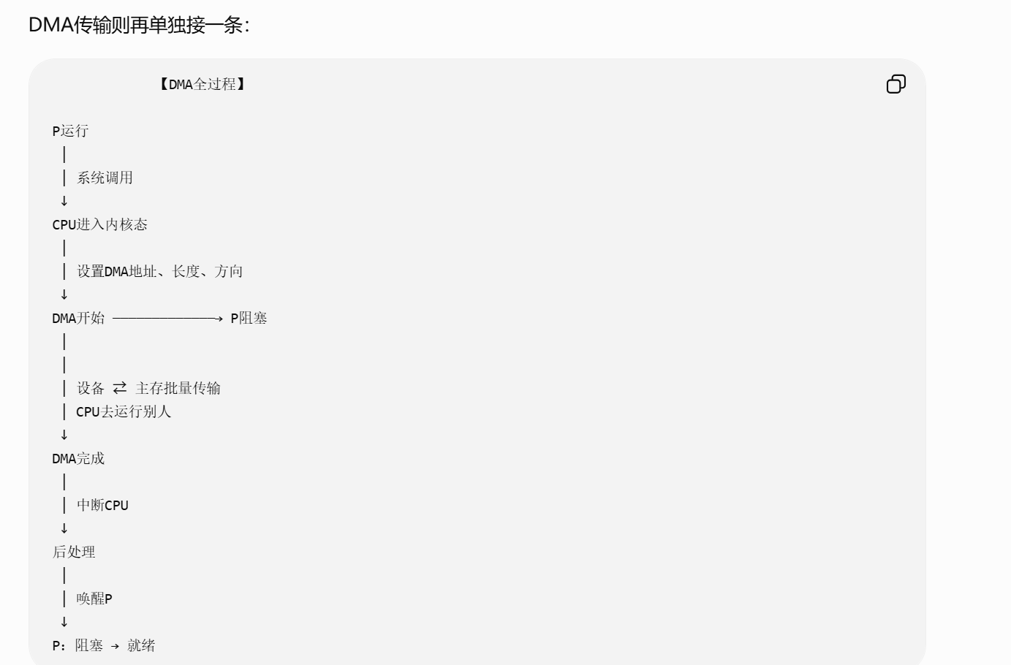
https://chatgpt.com/g/g-p-6a4147b6a8088191bef869eb87bbe5c0-cao-zuo-xi-tong/c/6a8835db-ed68-83ee-80be-cf04b1ac522a

5.2设备独立性软件:

缓冲区计算问题：
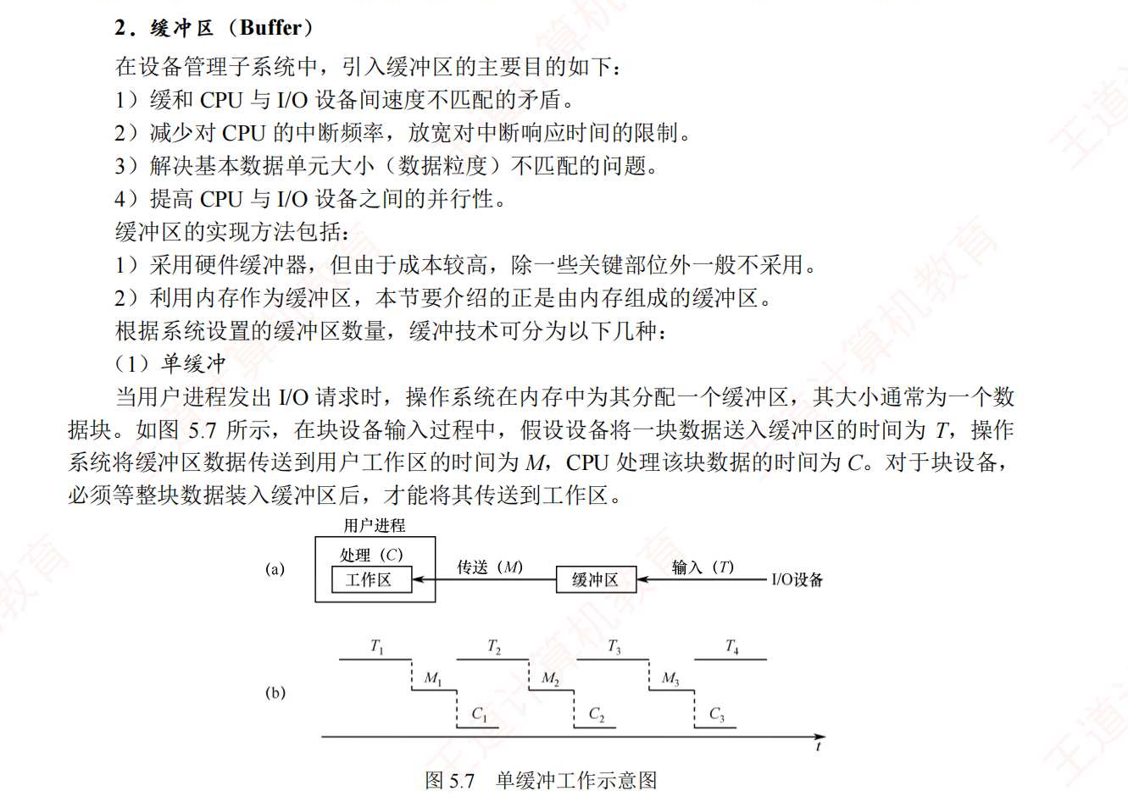
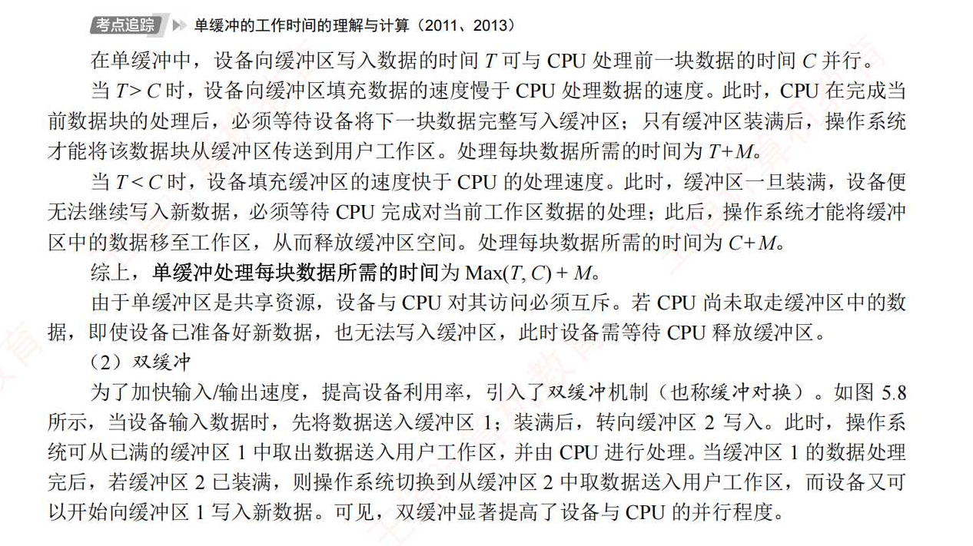
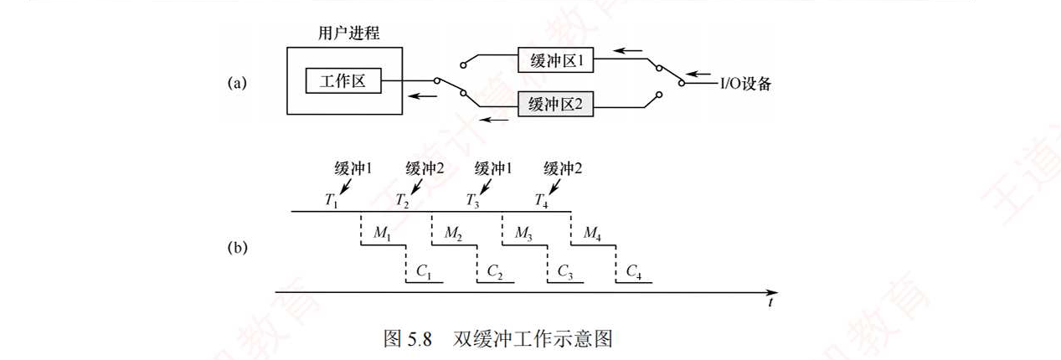
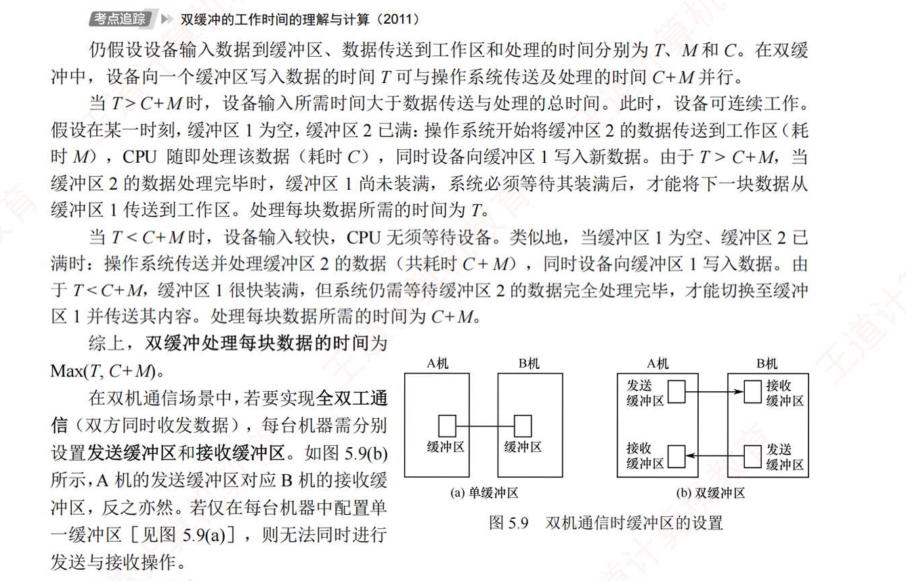
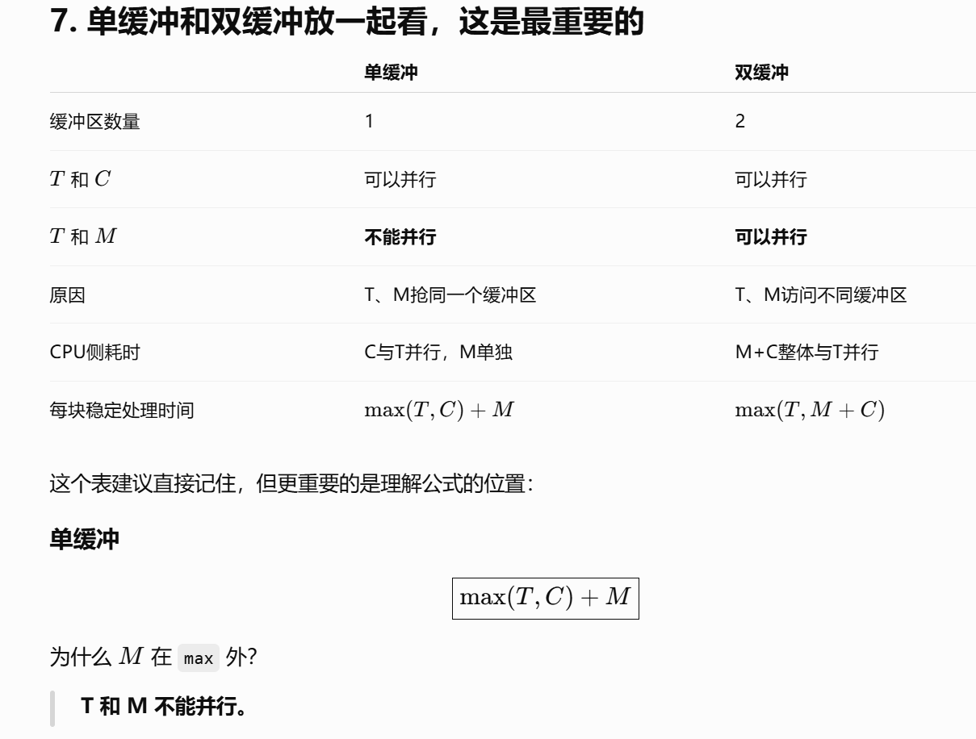
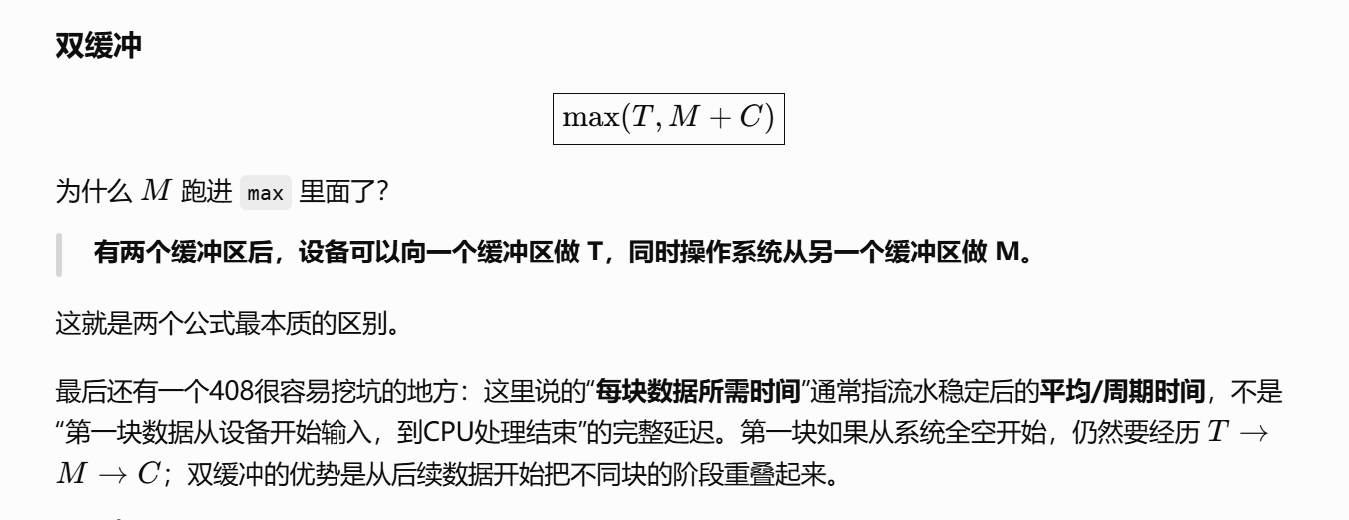
https://chatgpt.com/g/g-p-6a4147b6a8088191bef869eb87bbe5c0-cao-zuo-xi-tong/c/6a8a8af0-9c78-83e8-b8d9-d4b79cec3a35

SPOOLing技术：
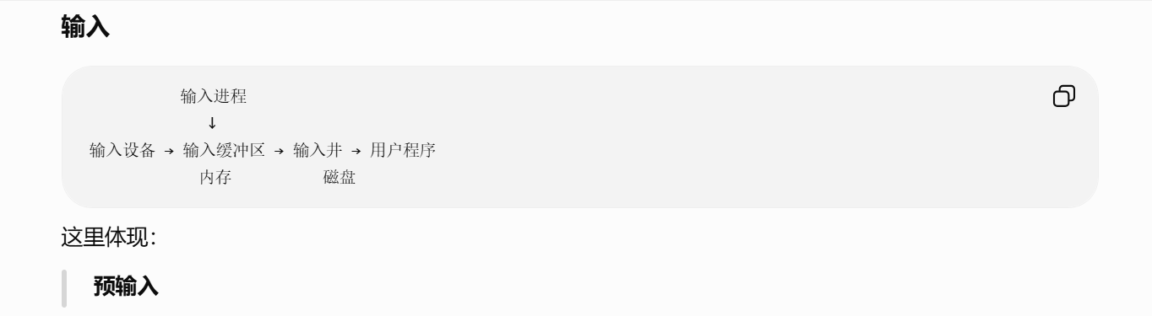
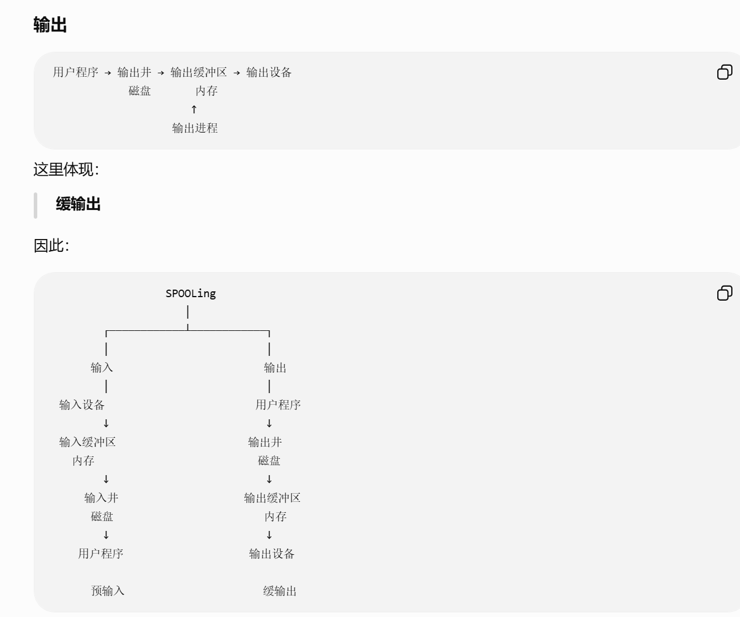
https://chatgpt.com/g/g-p-6a4147b6a8088191bef869eb87bbe5c0-cao-zuo-xi-tong/c/6a8aa228-219c-83e8-b389-2b868885914e

5.3磁盘和固态硬盘：
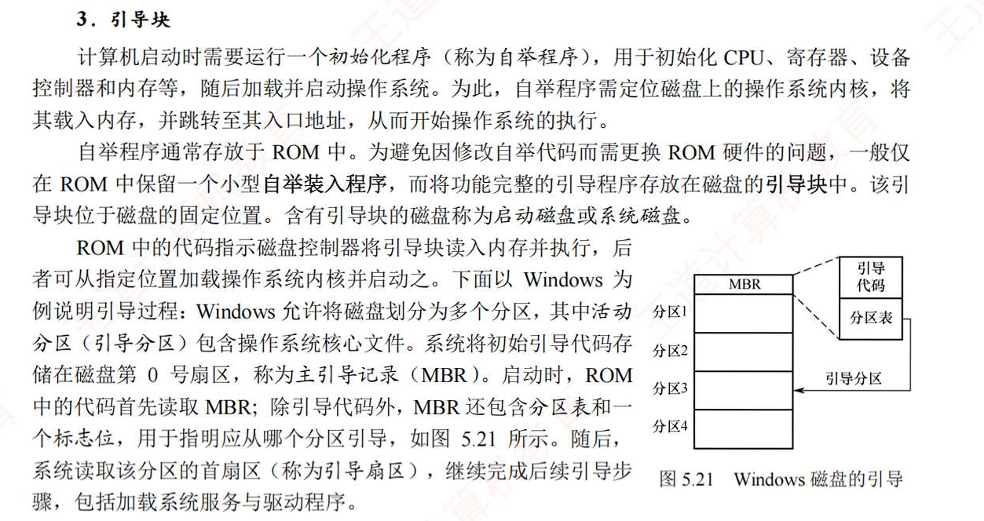
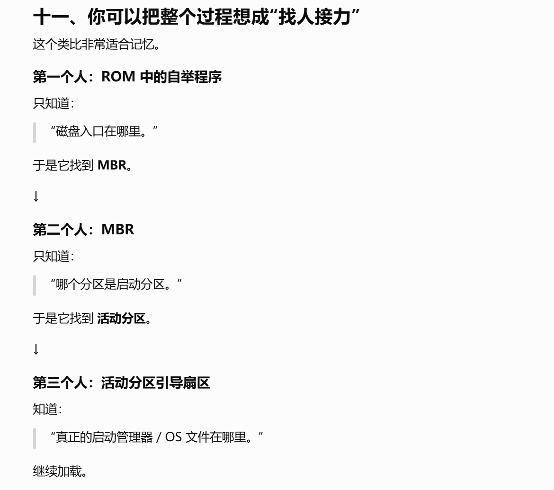
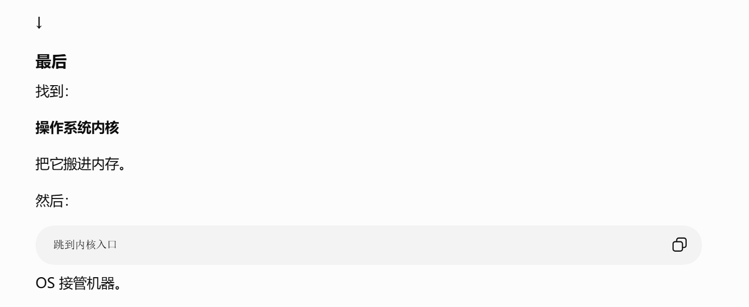
https://chatgpt.com/g/g-p-6a4147b6a8088191bef869eb87bbe5c0-cao-zuo-xi-tong/c/6a8c3b87-41d8-83e9-86e2-e740e8c59727

概念：

设备控制器和设备驱动程序：
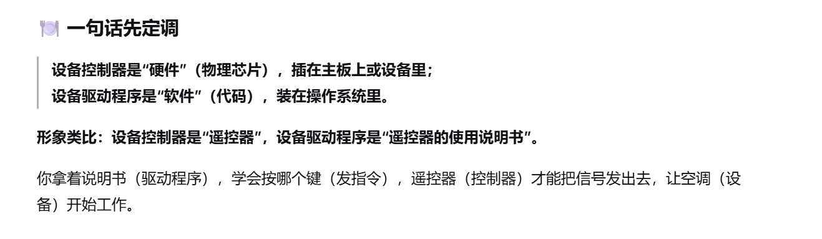
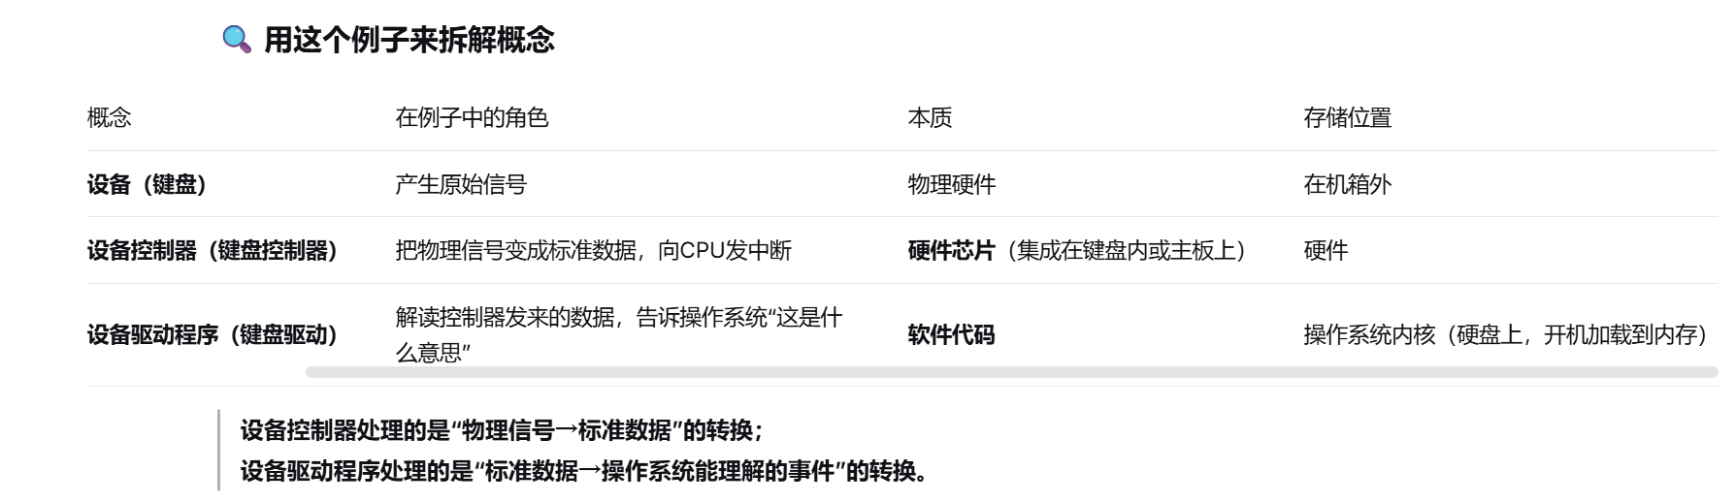
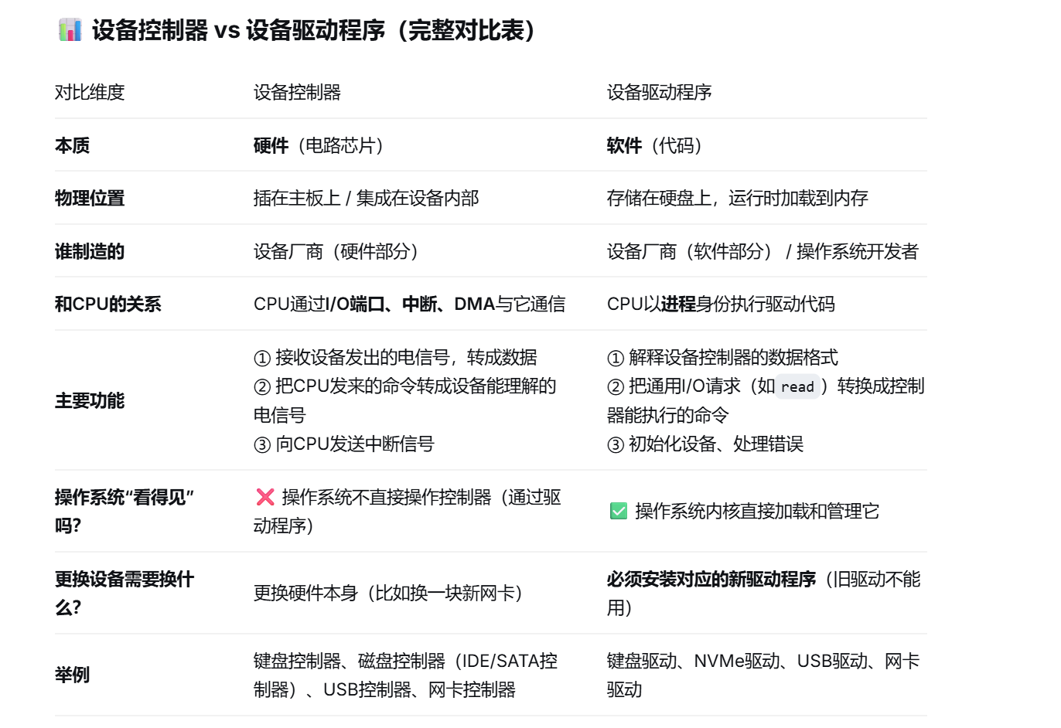

设备独立性软件和设备驱动程序：
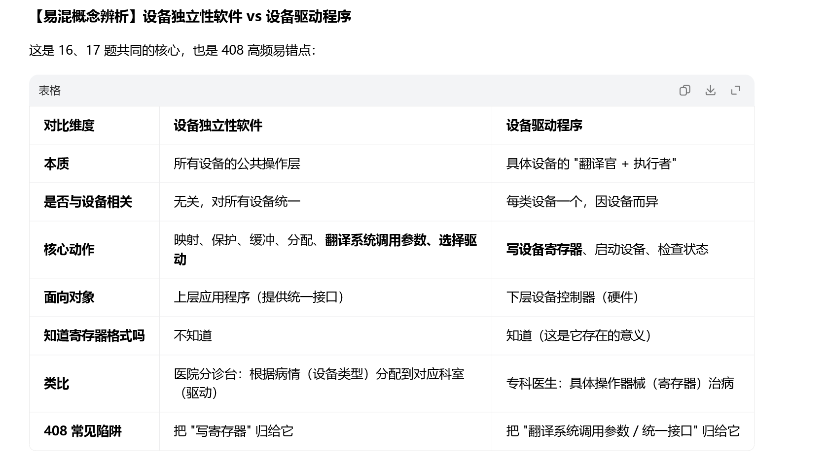

I/O完成:
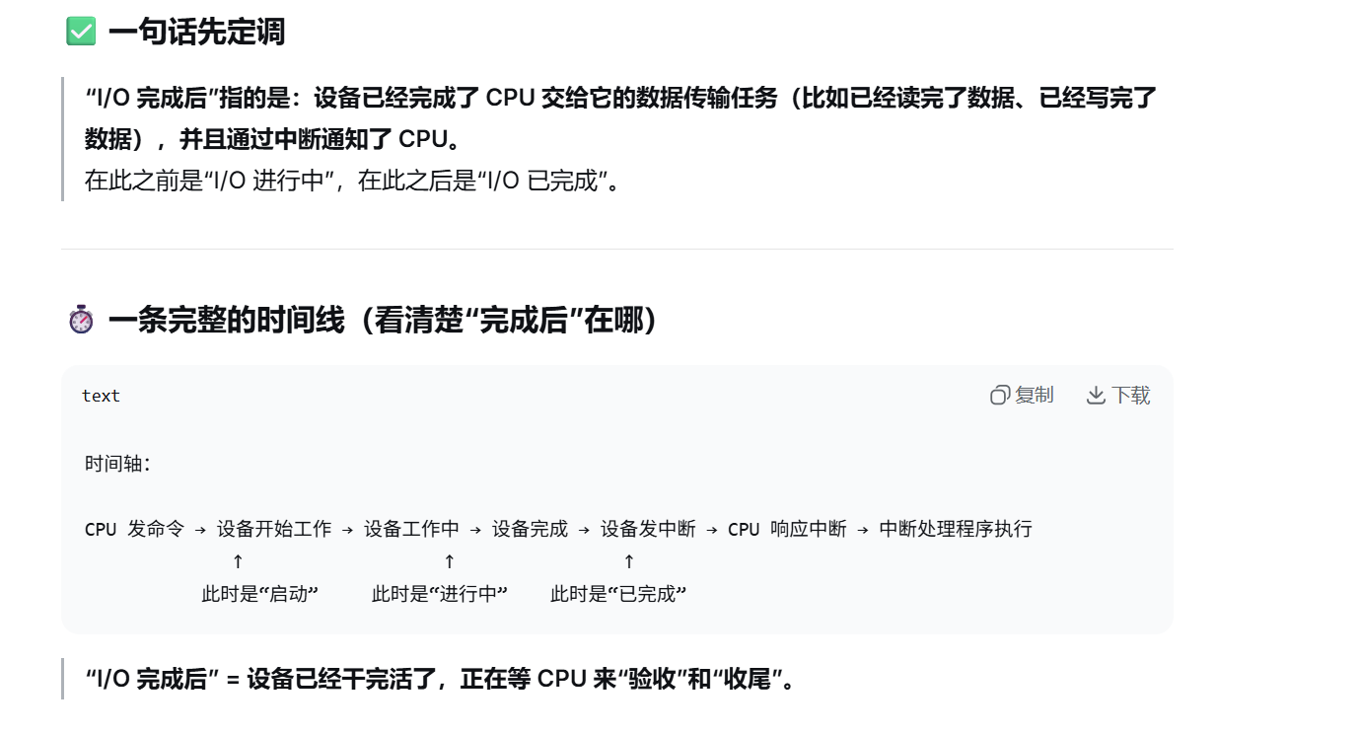
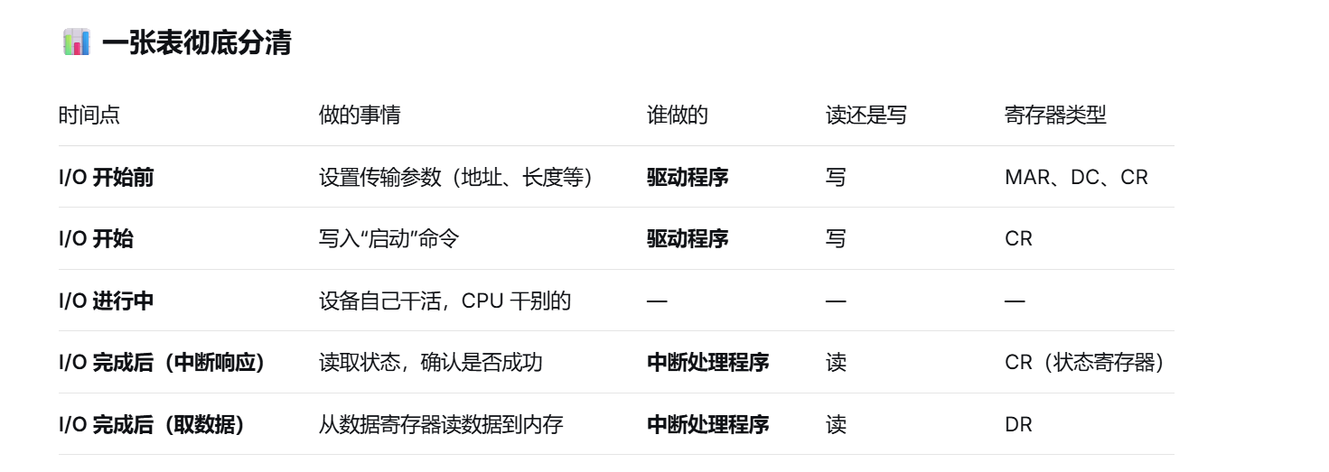
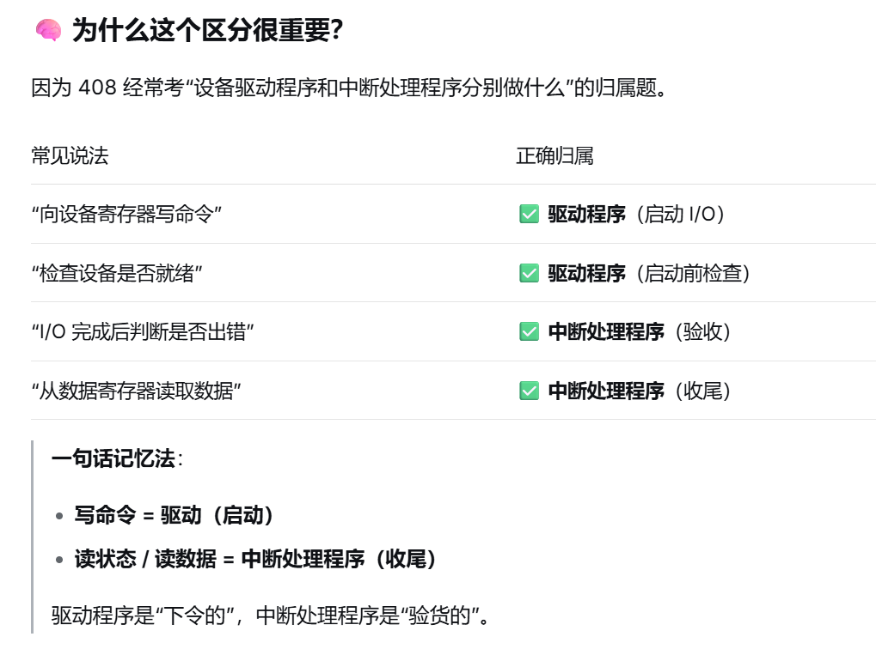

SPOOLing:
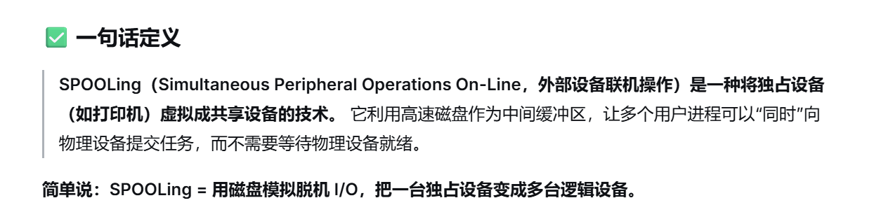
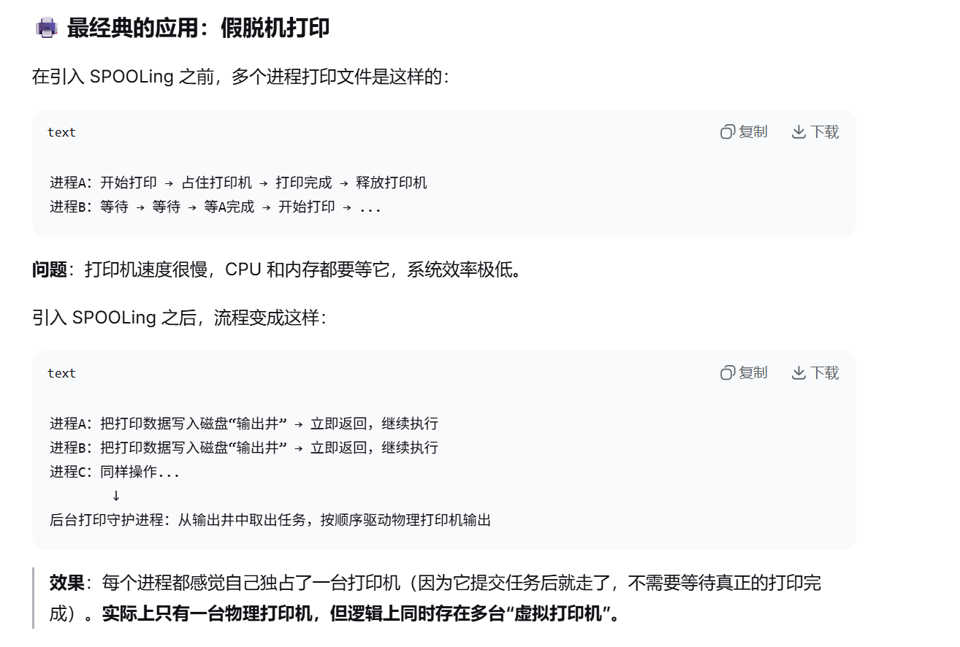
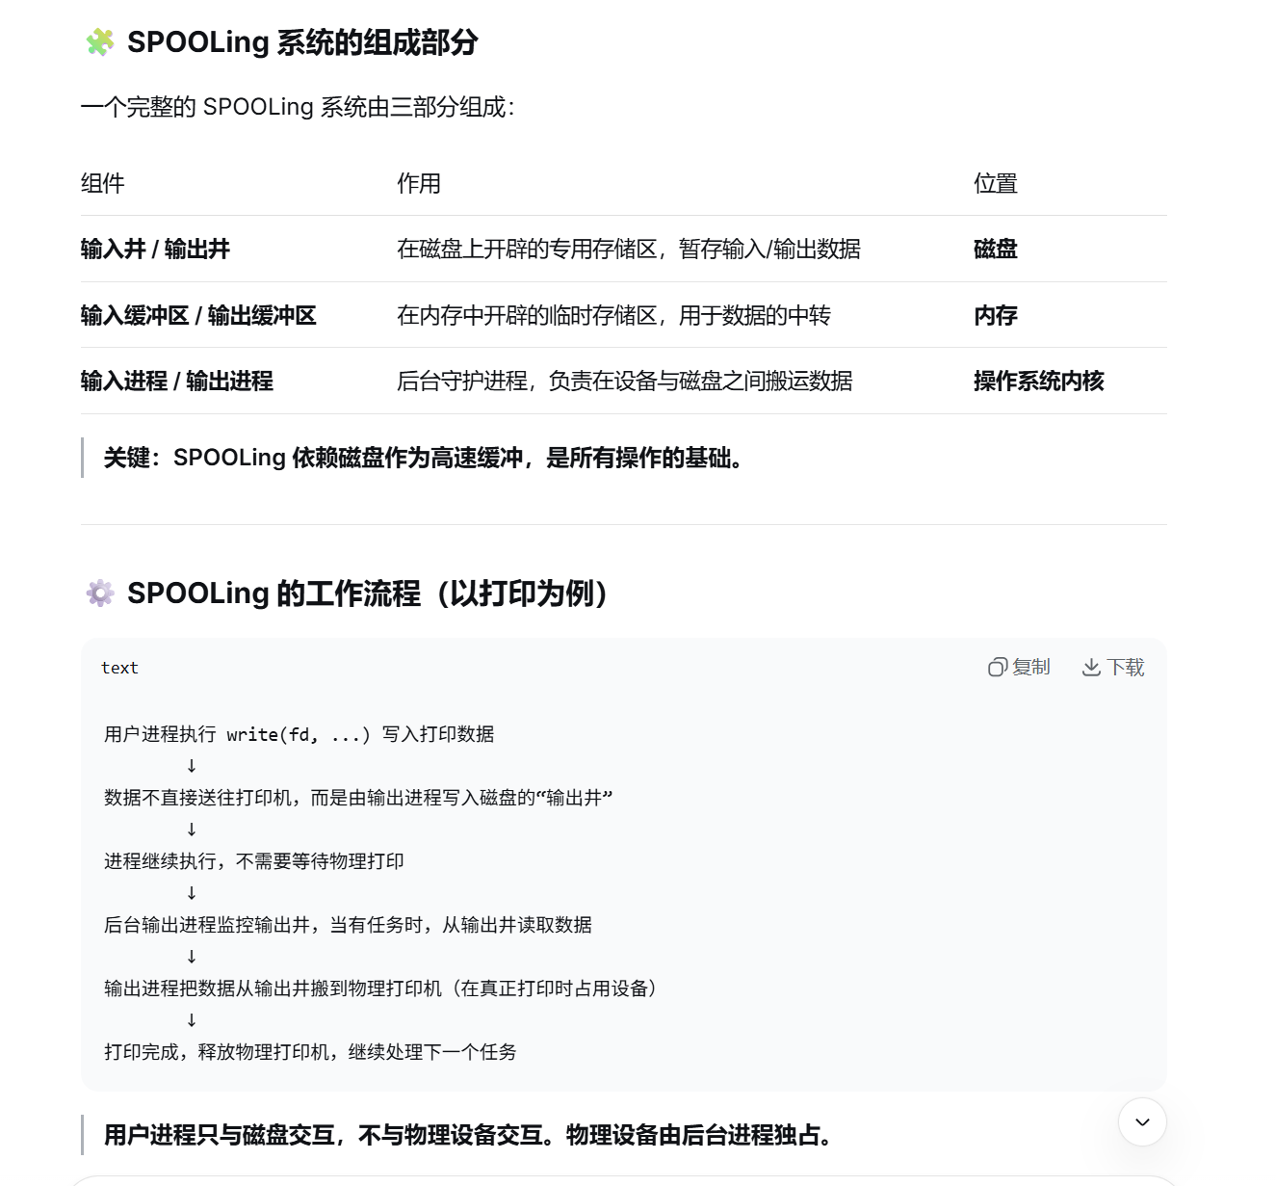
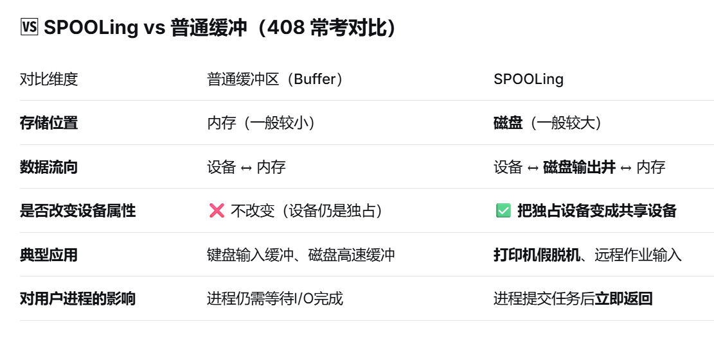
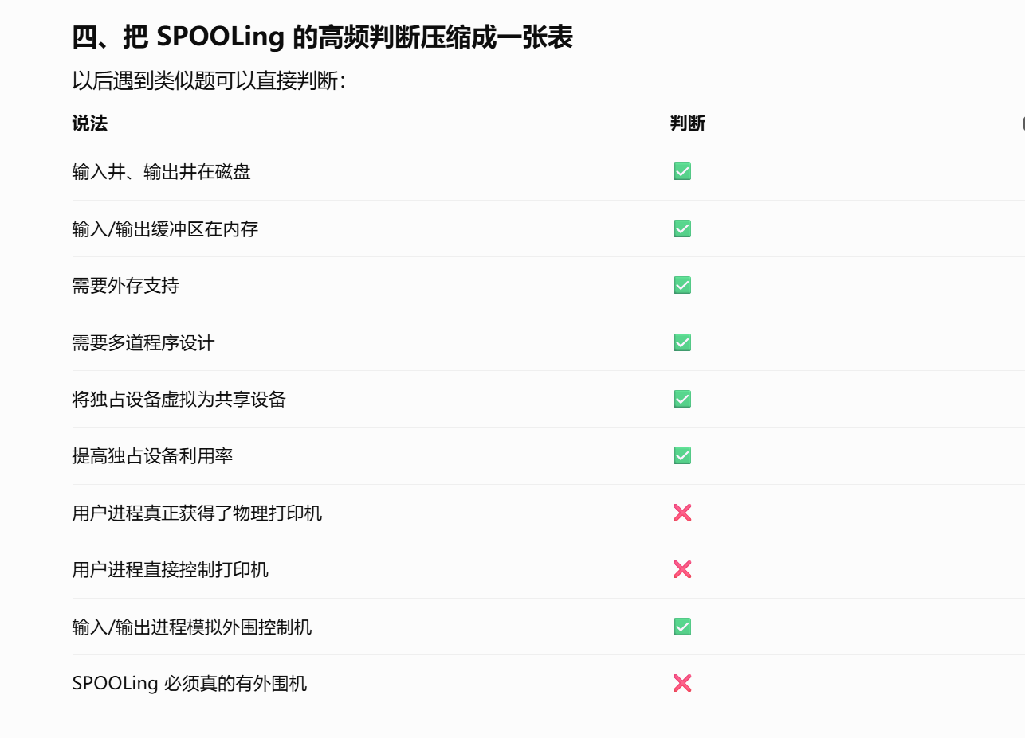

通道：
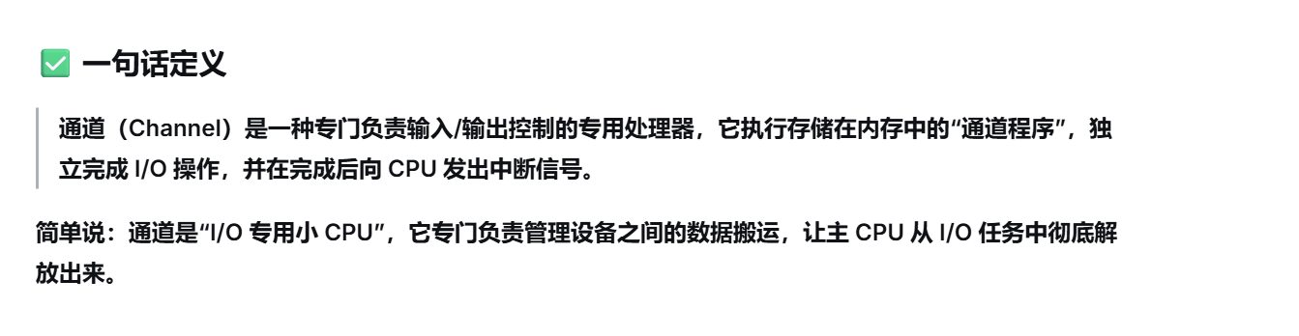
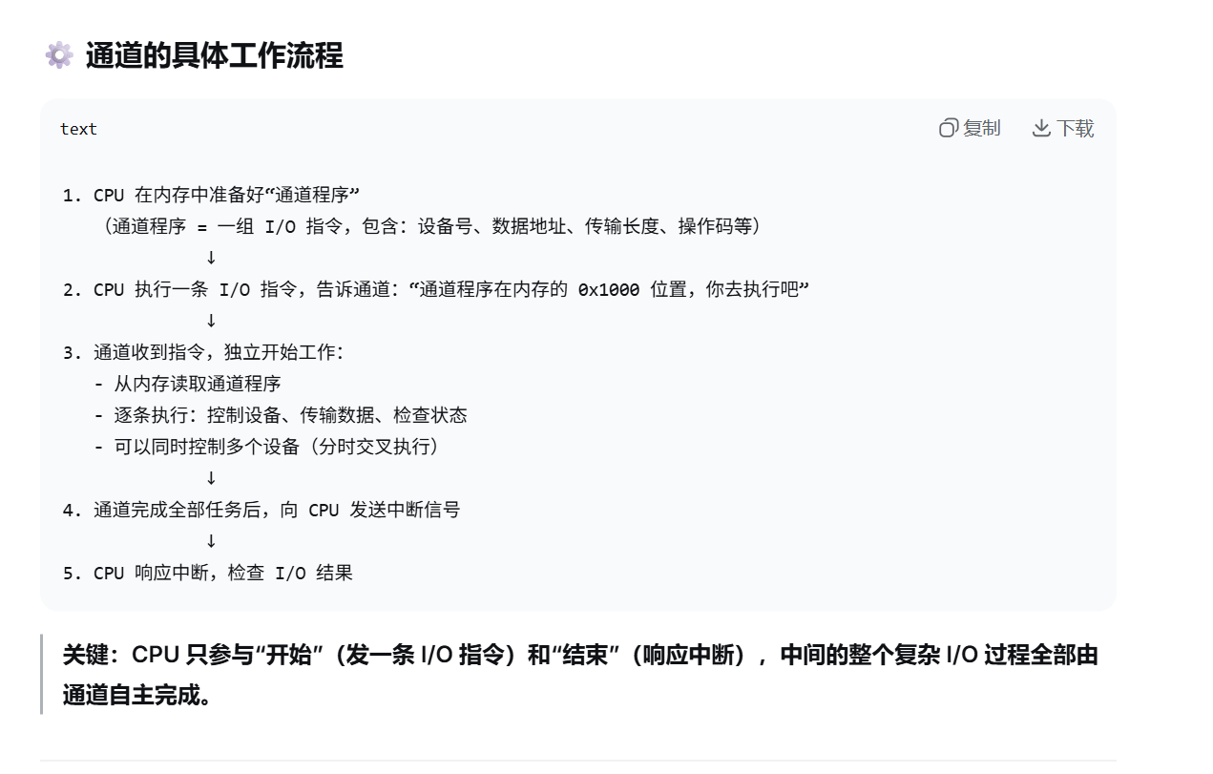
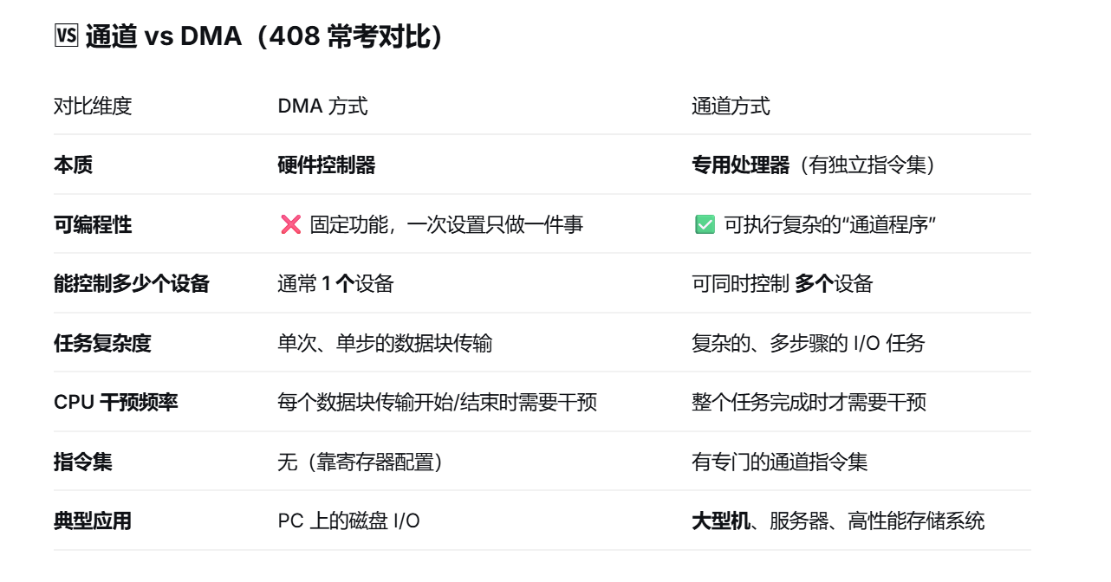

DMA：
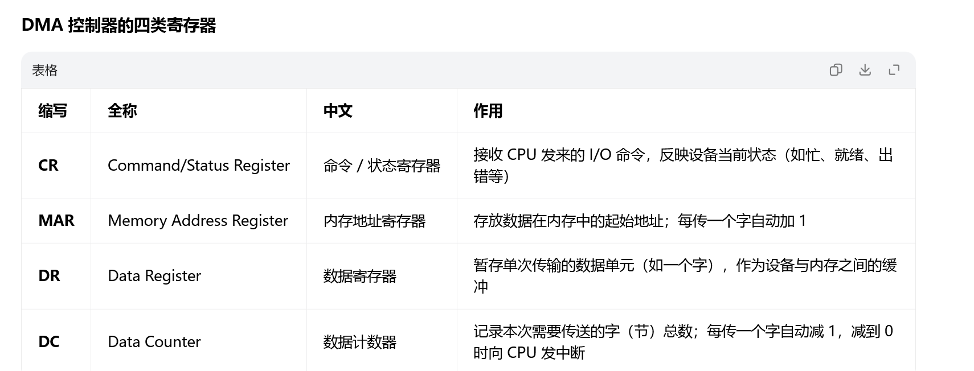
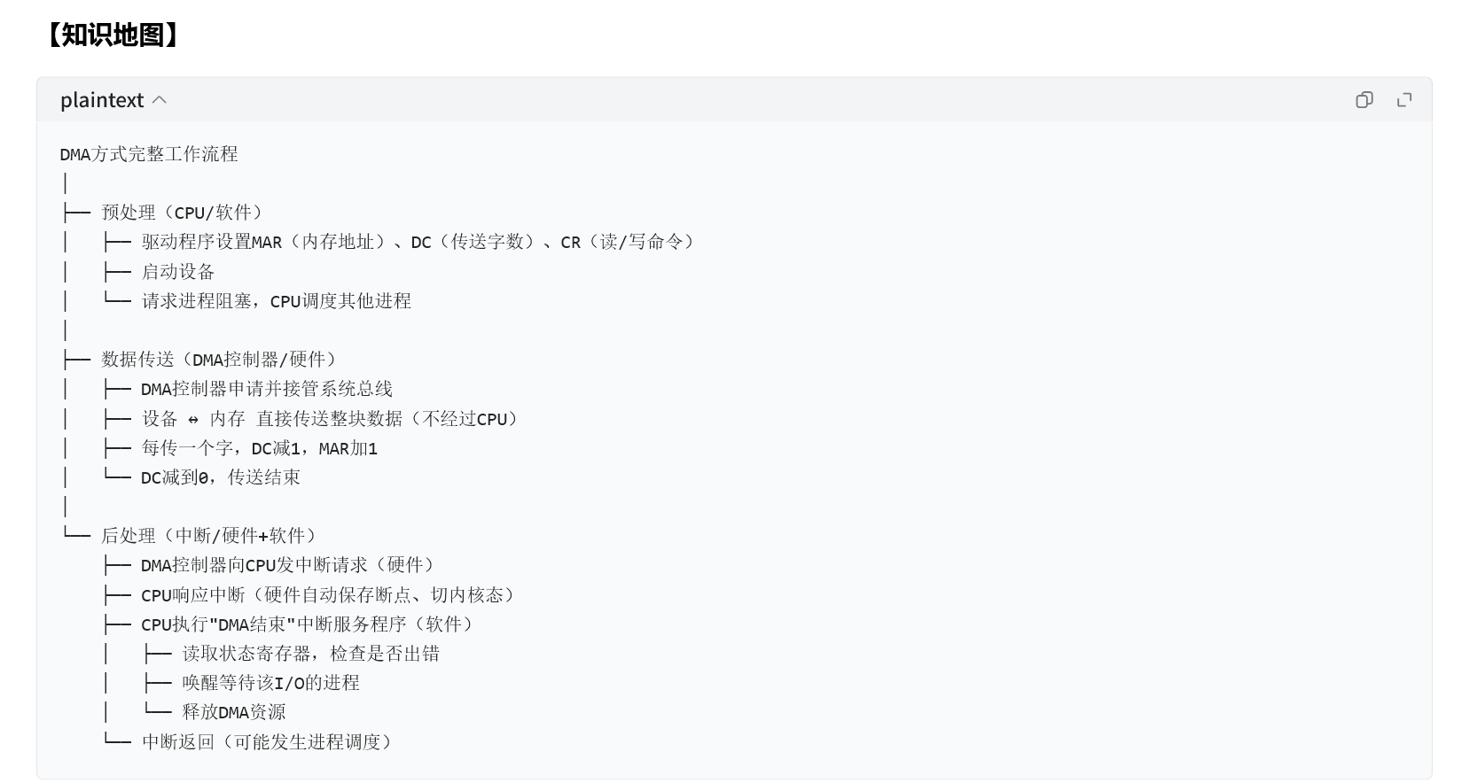

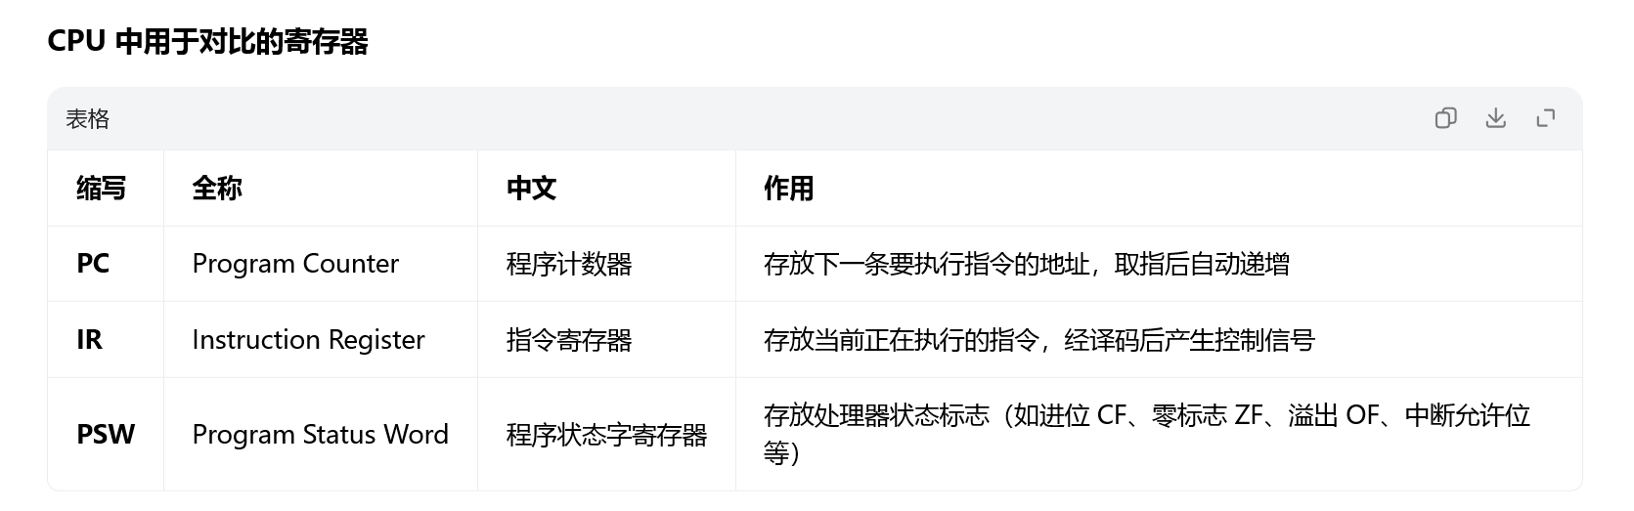

中断与DMA:
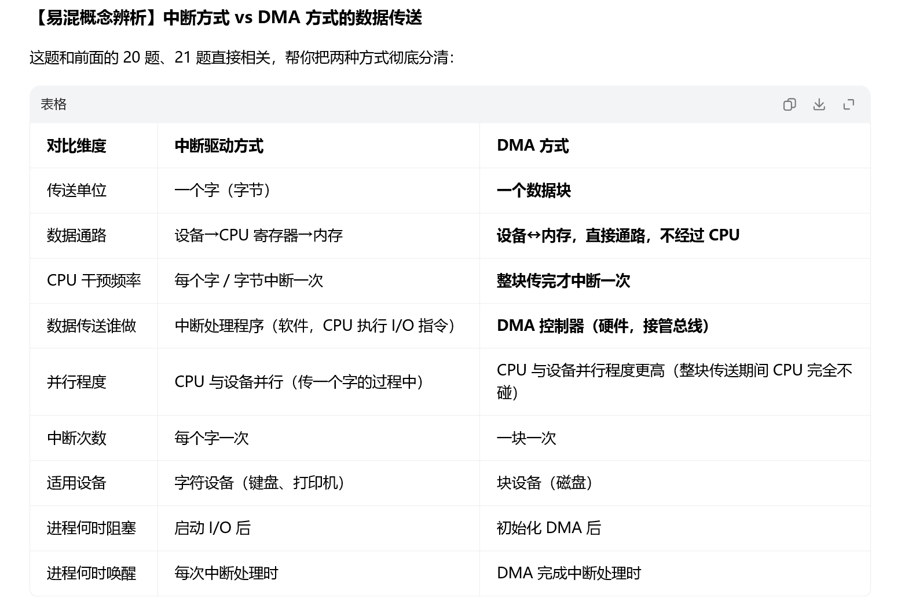
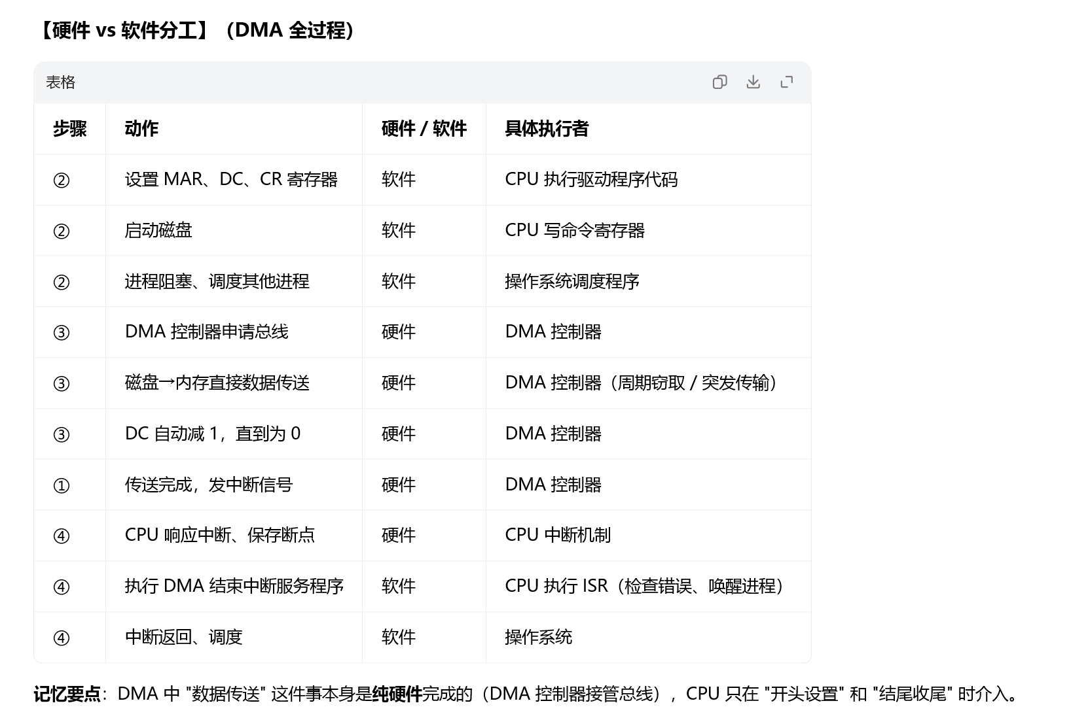

DCT、COCT、CHCT、SDT：
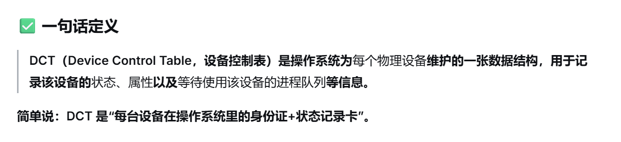
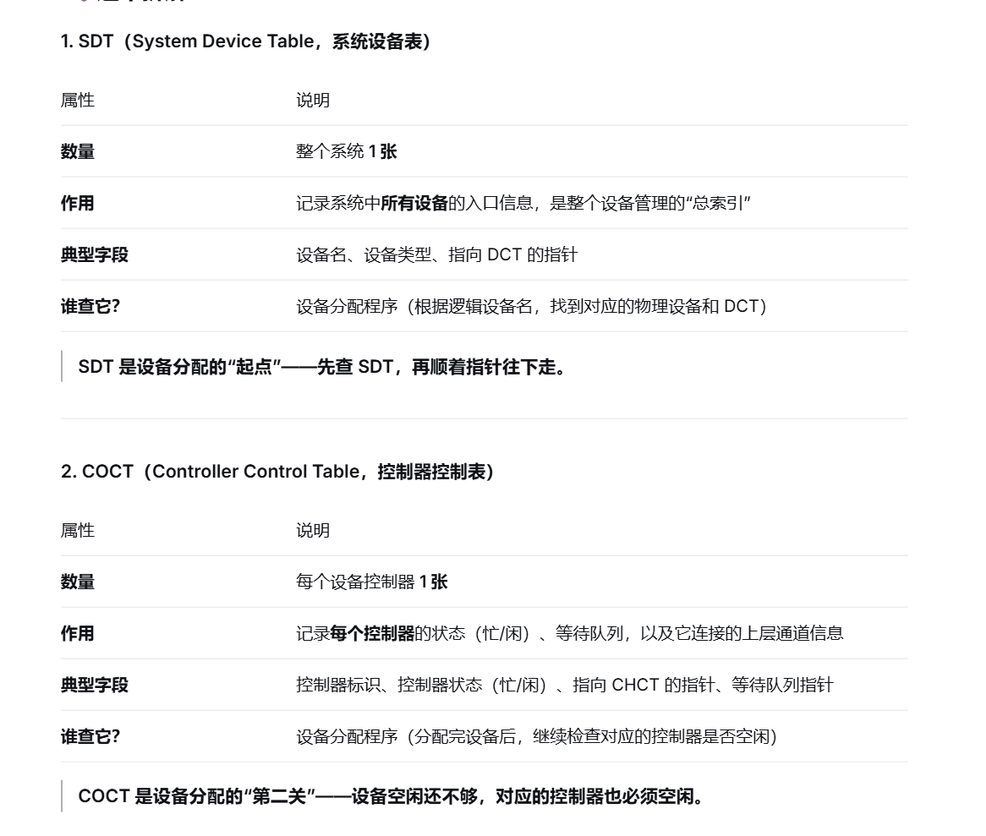
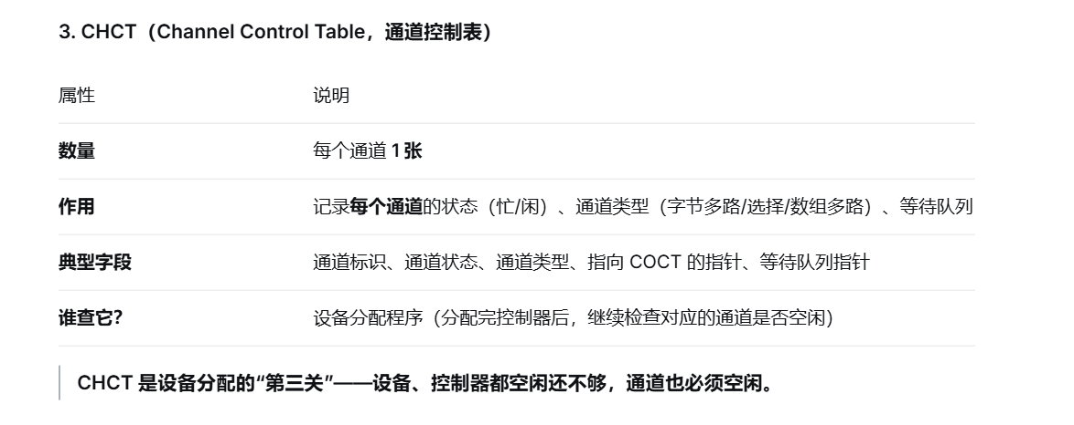

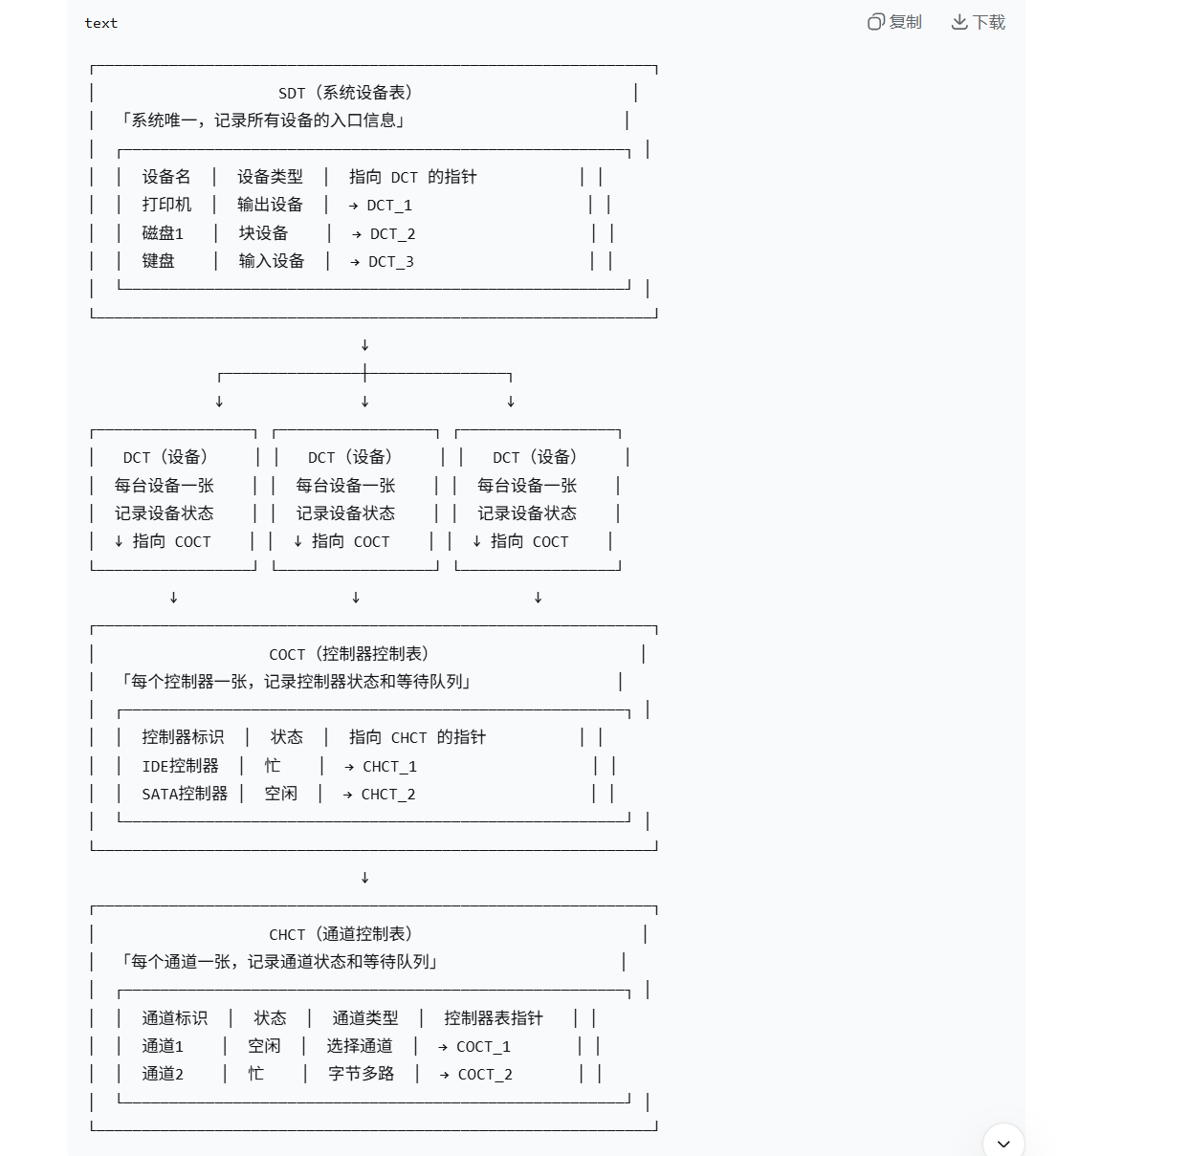

设备的独立性：
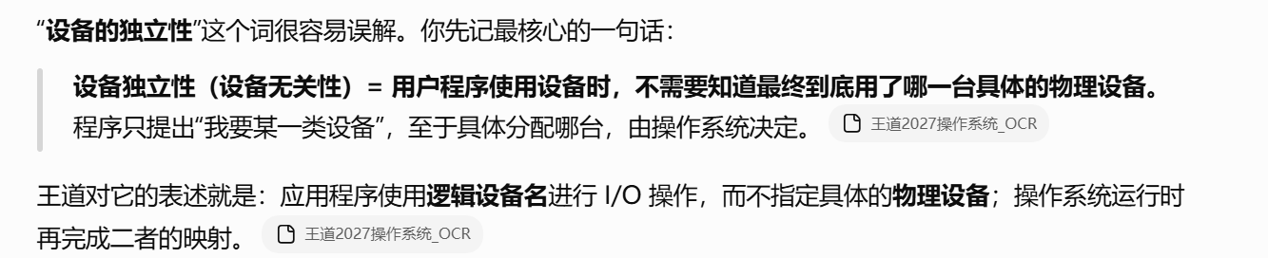
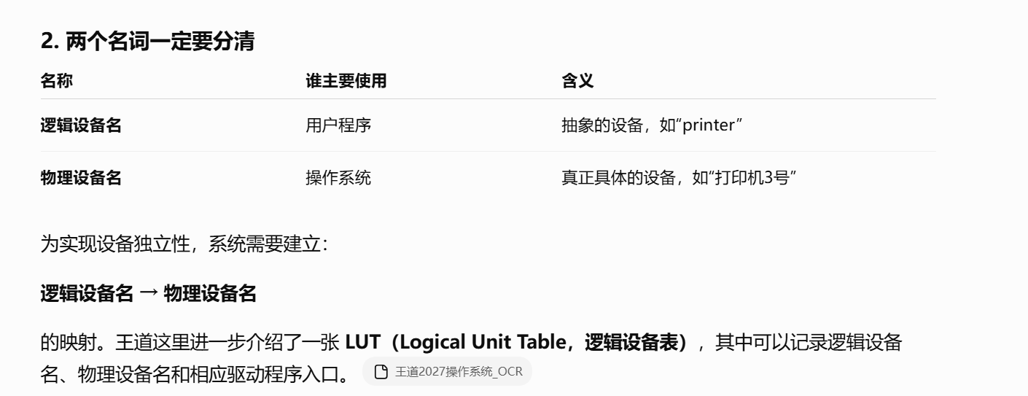
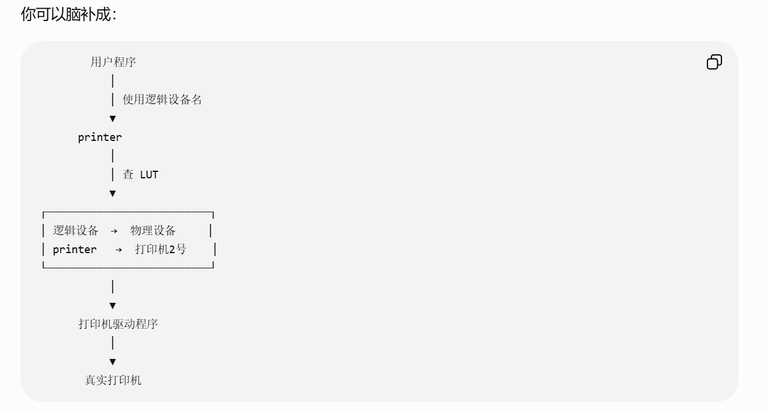
https://chatgpt.com/g/g-p-6a4147b6a8088191bef869eb87bbe5c0-cao-zuo-xi-tong/c/6a8a9b62-bf88-83e8-9c21-d843723865d7

外围机：
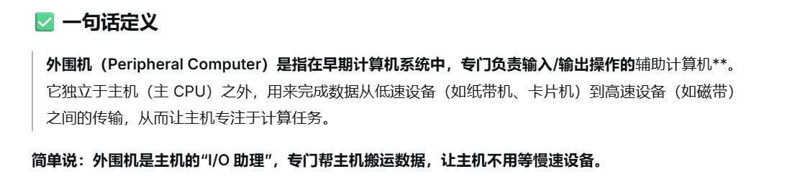

输入井和输出井：
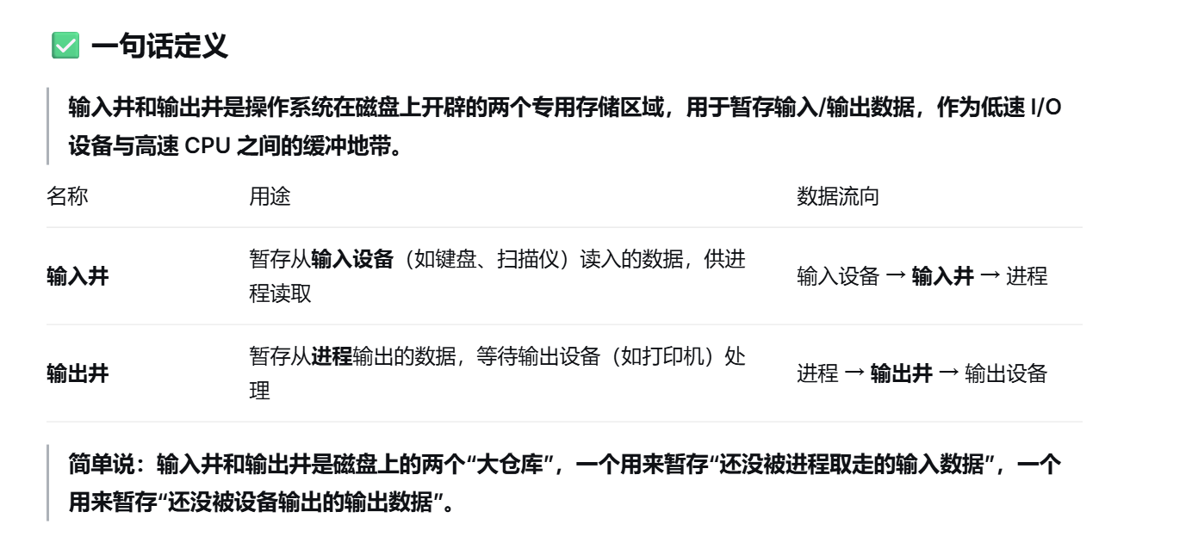
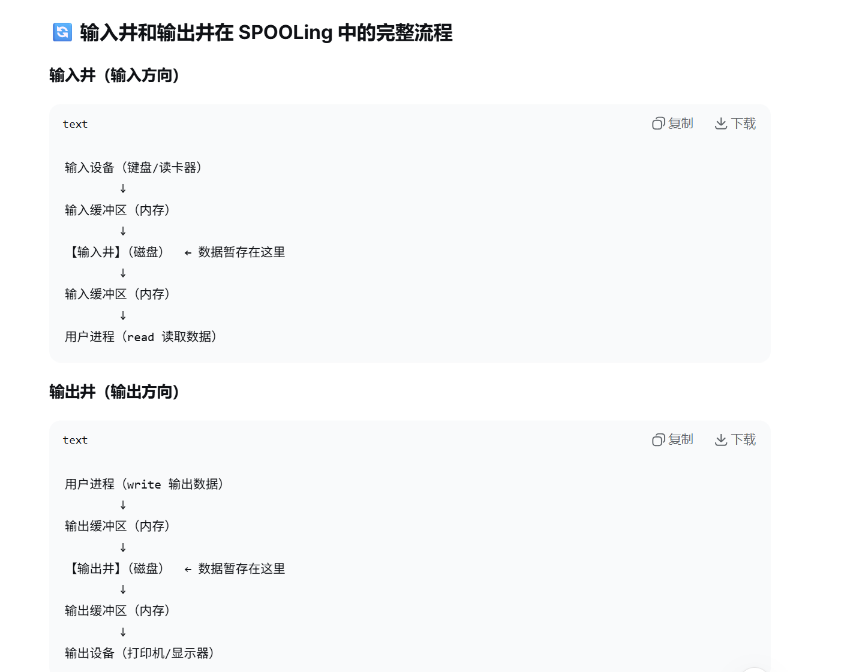
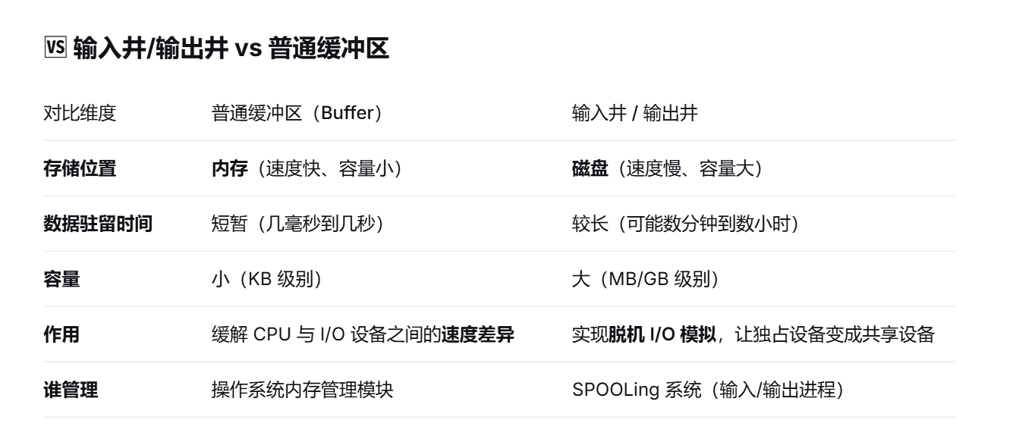

题：

题1：
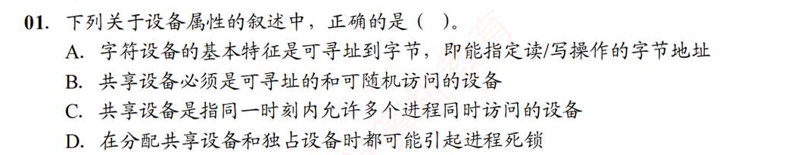
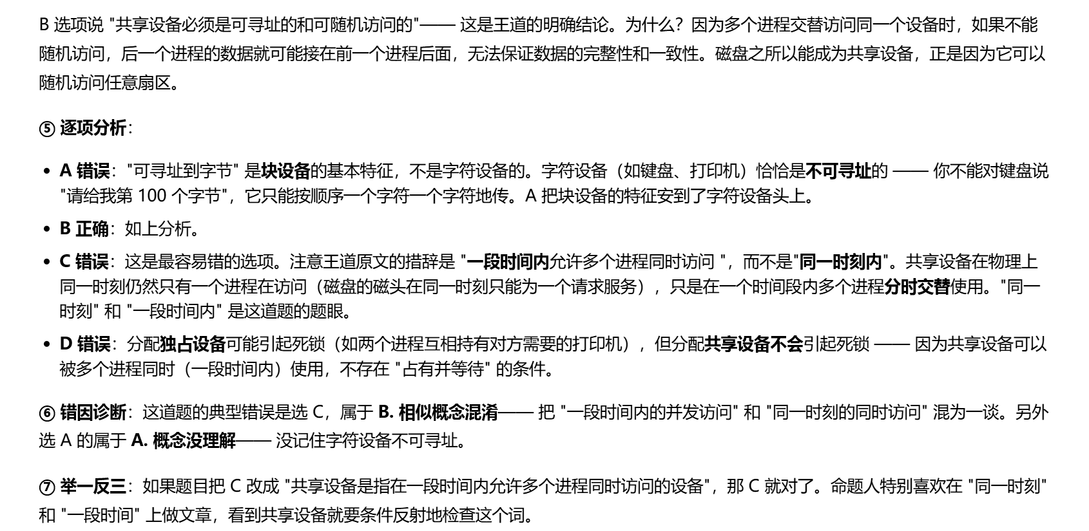

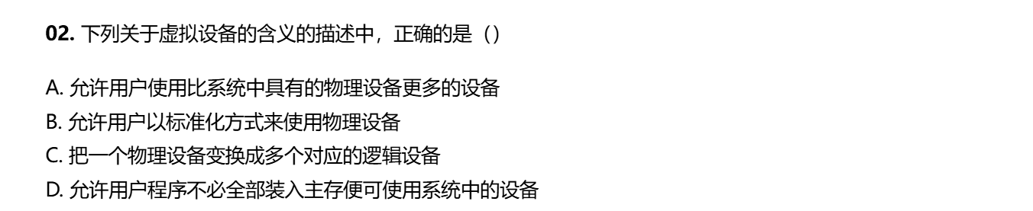
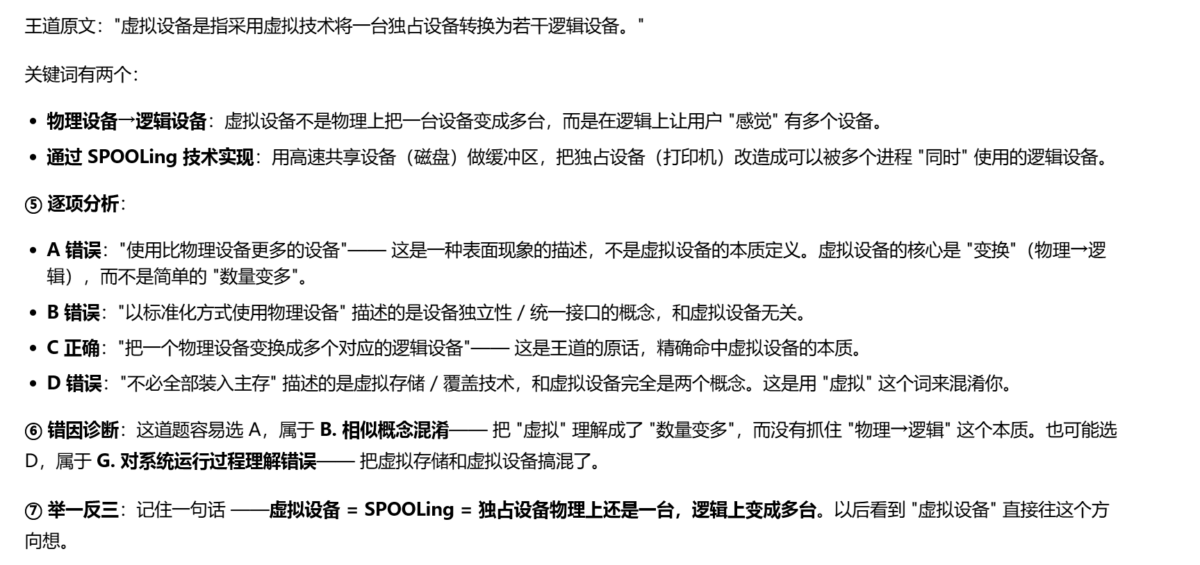
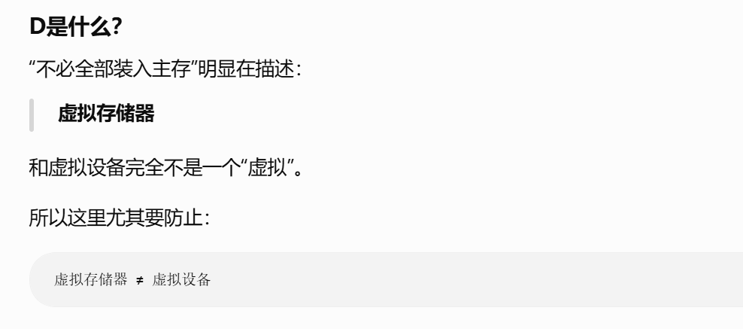

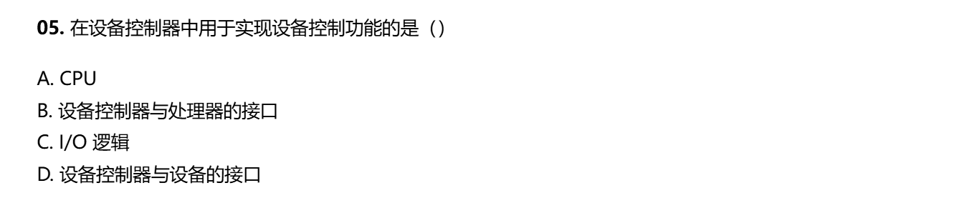
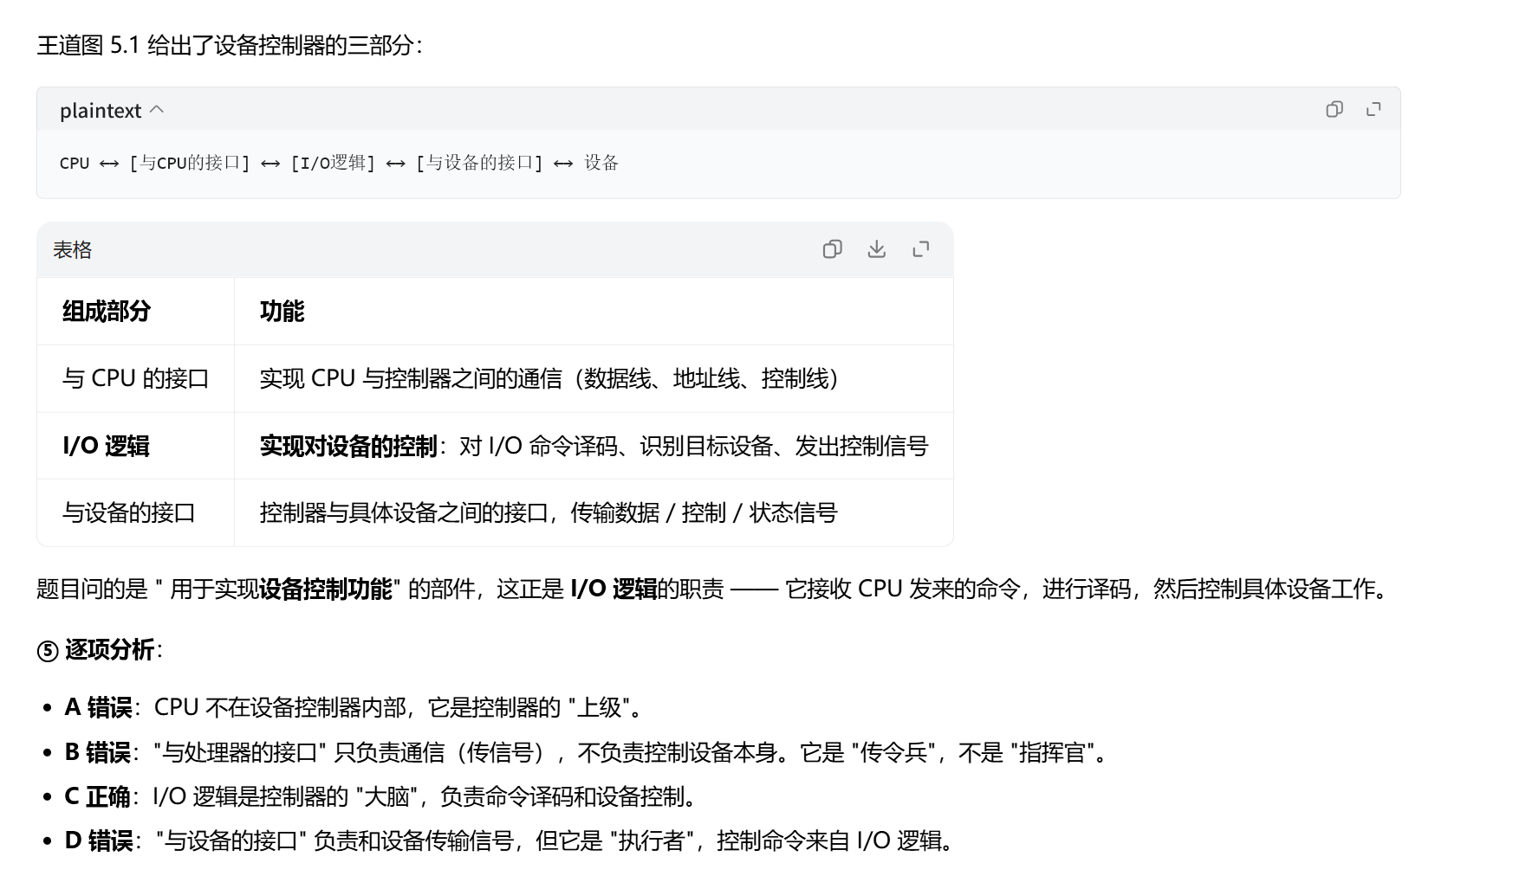

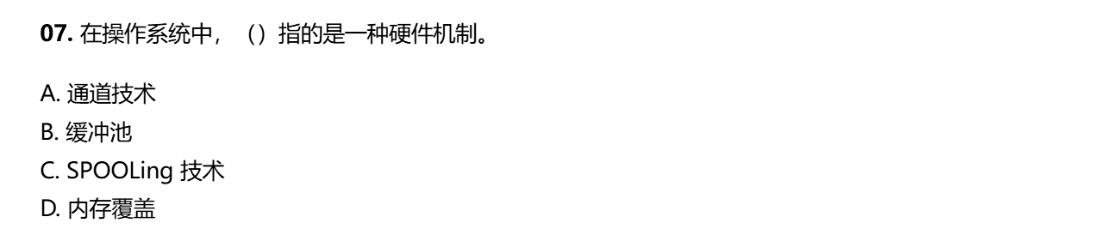
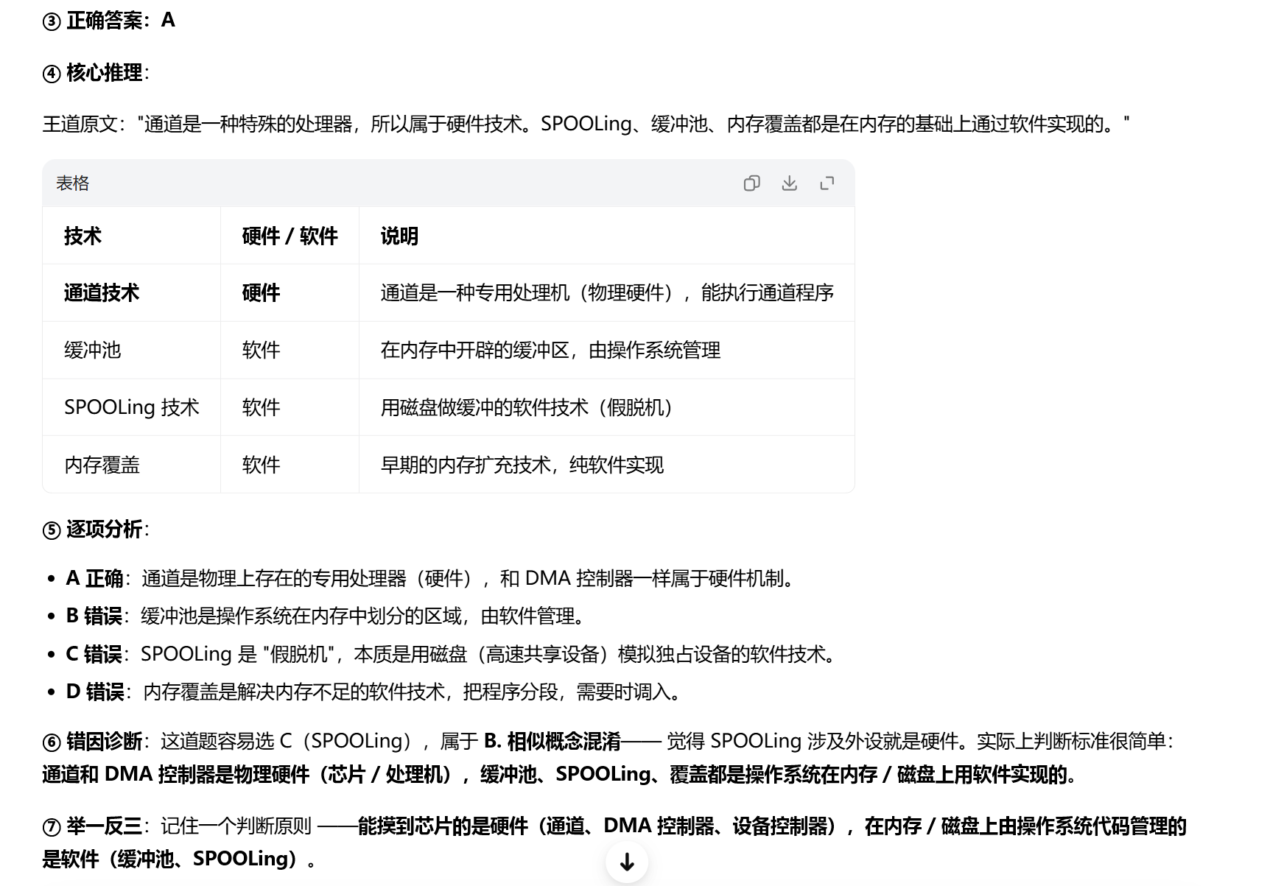
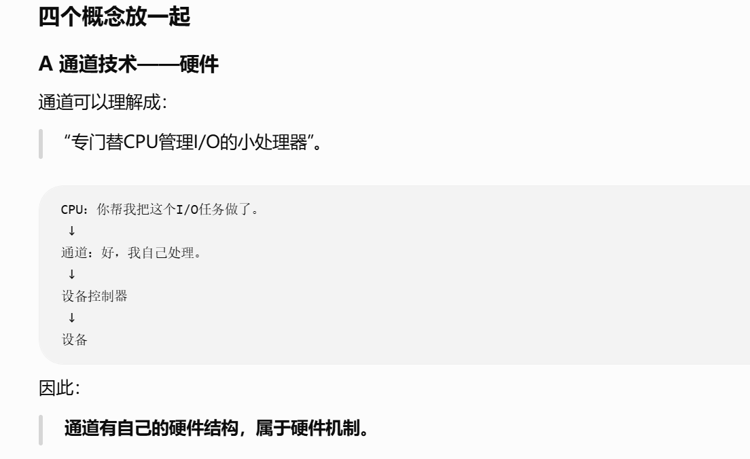
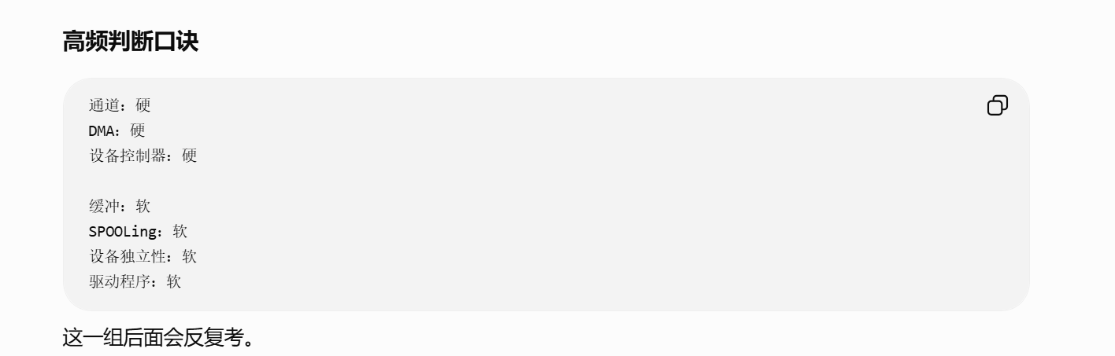

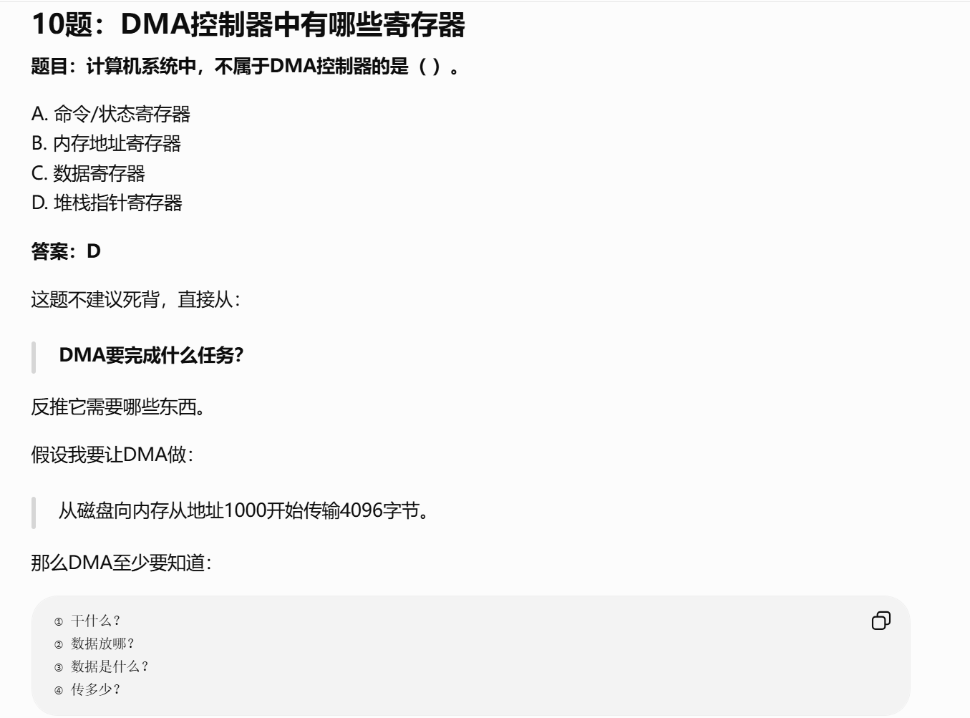
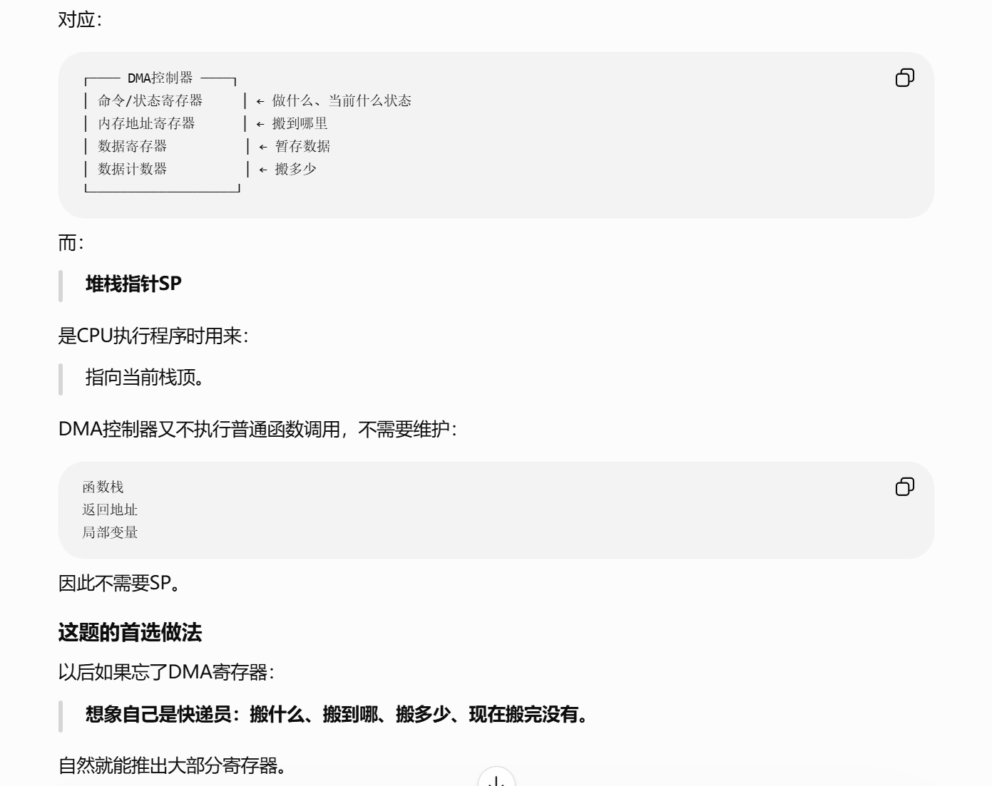
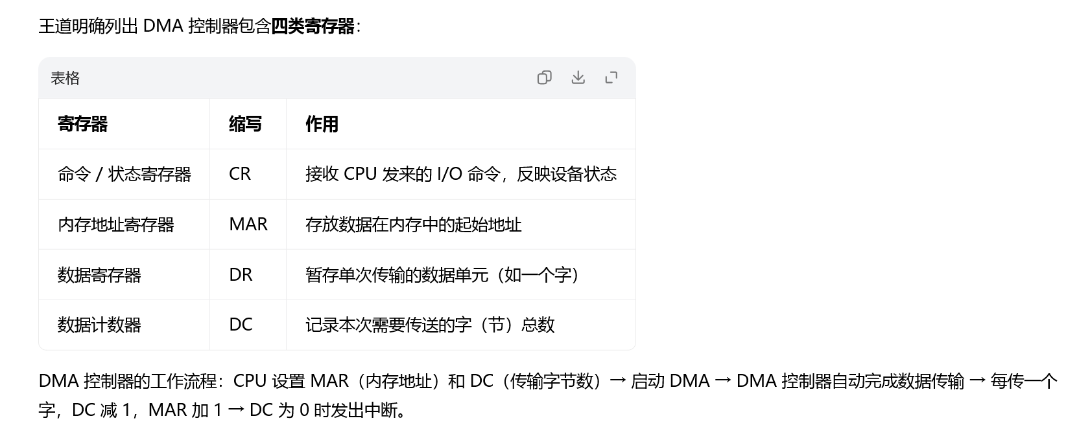

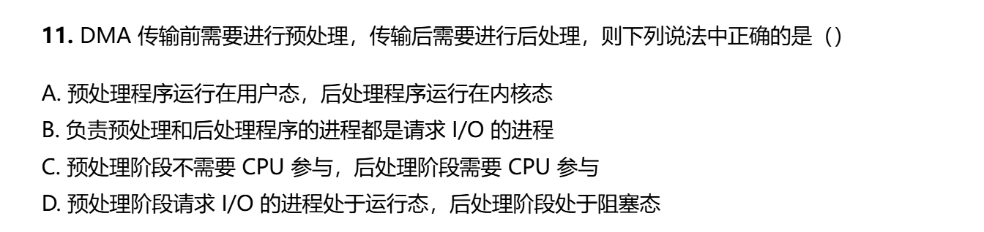
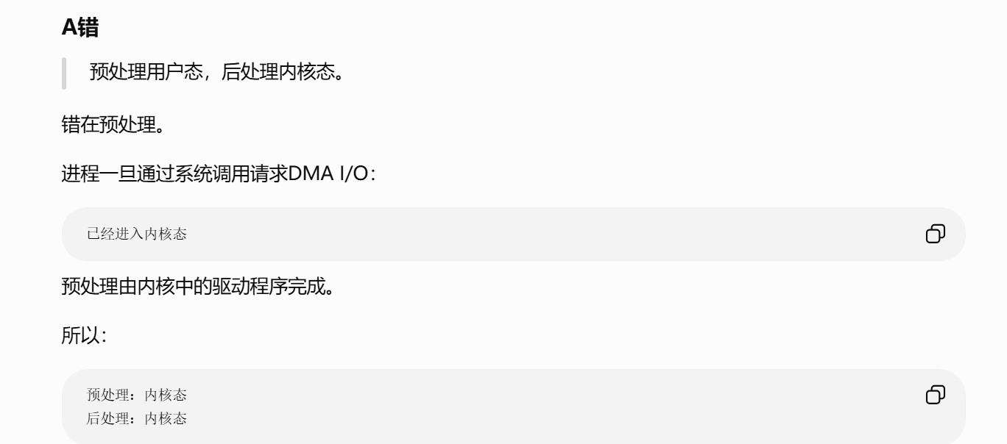
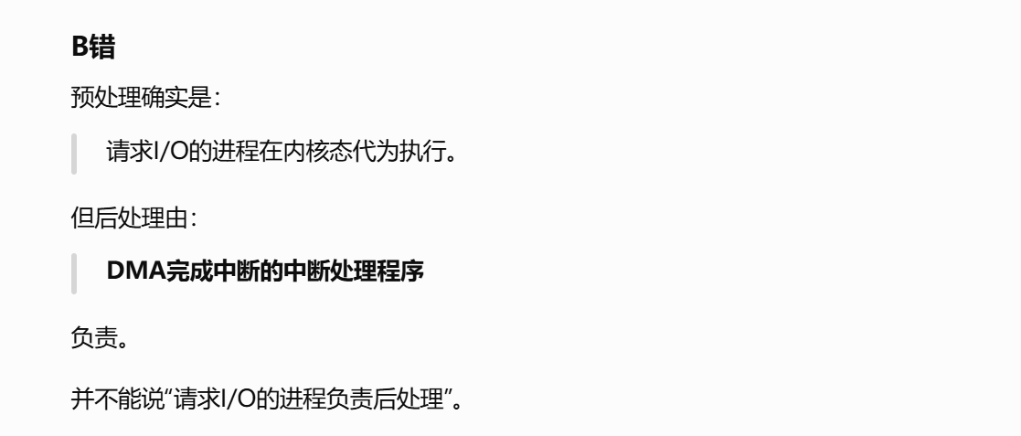
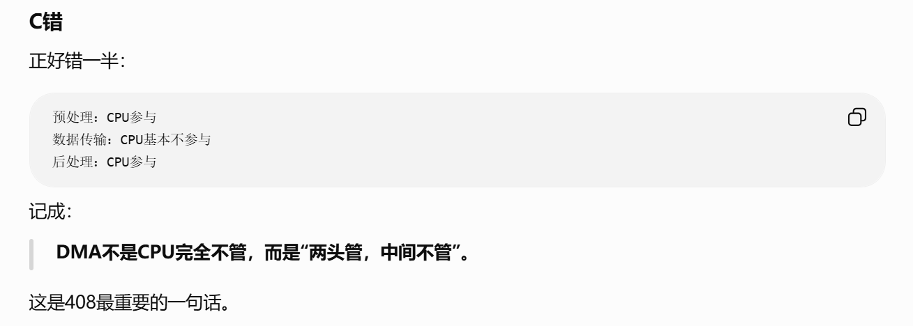
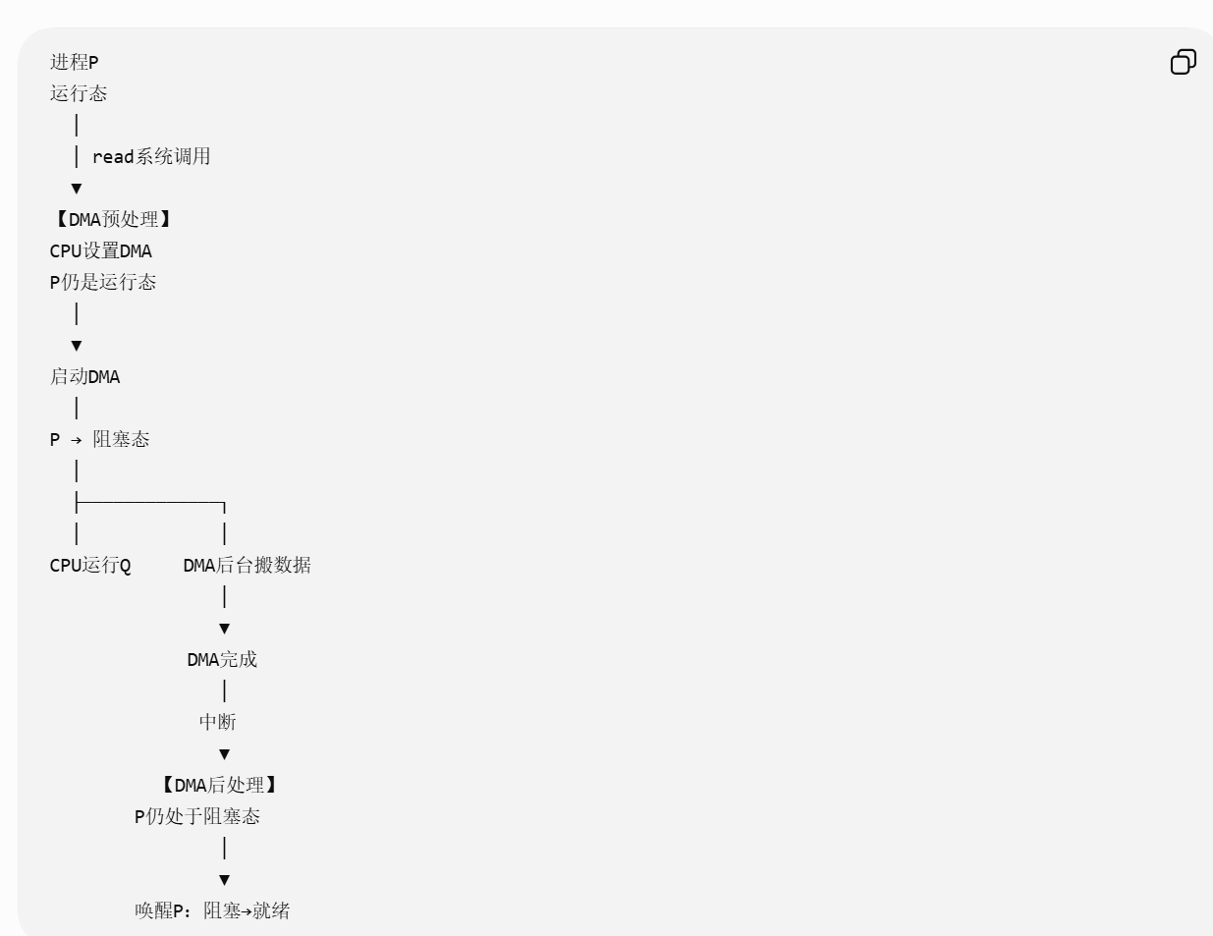

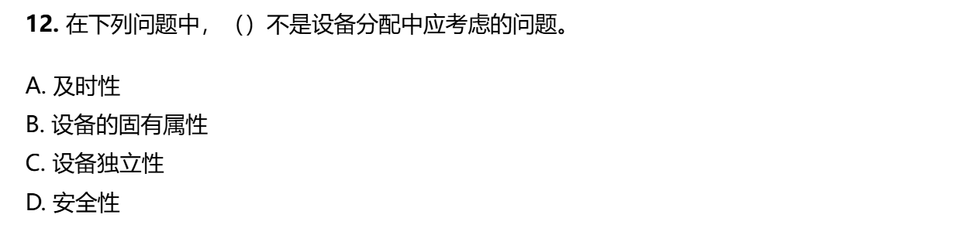
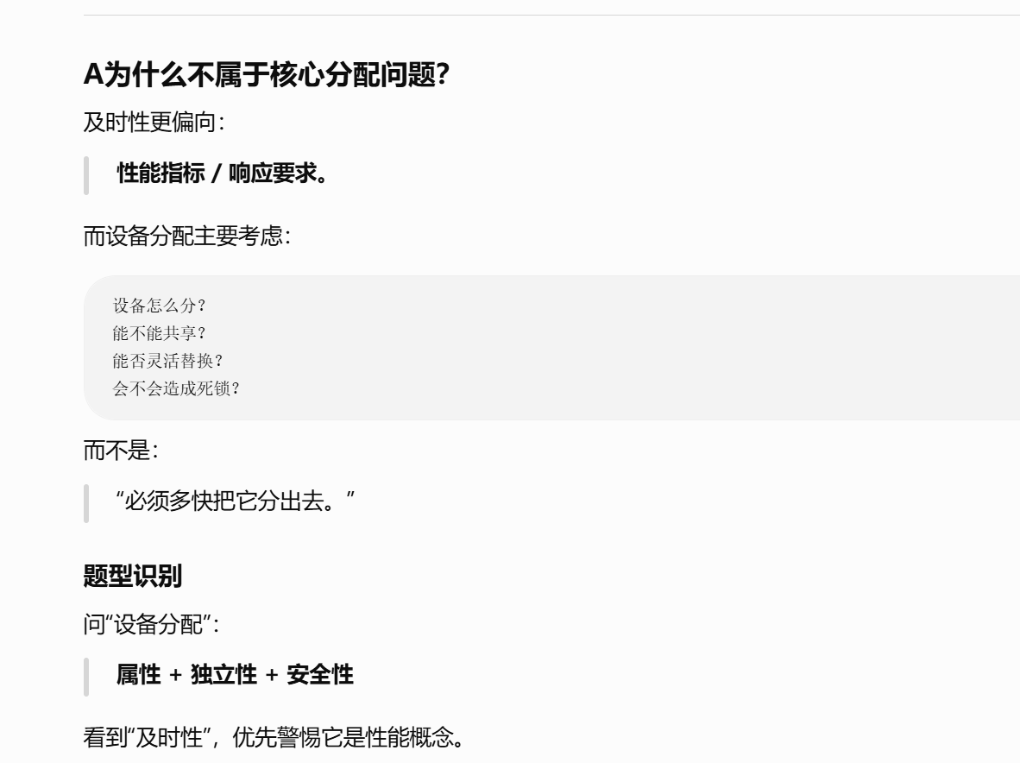
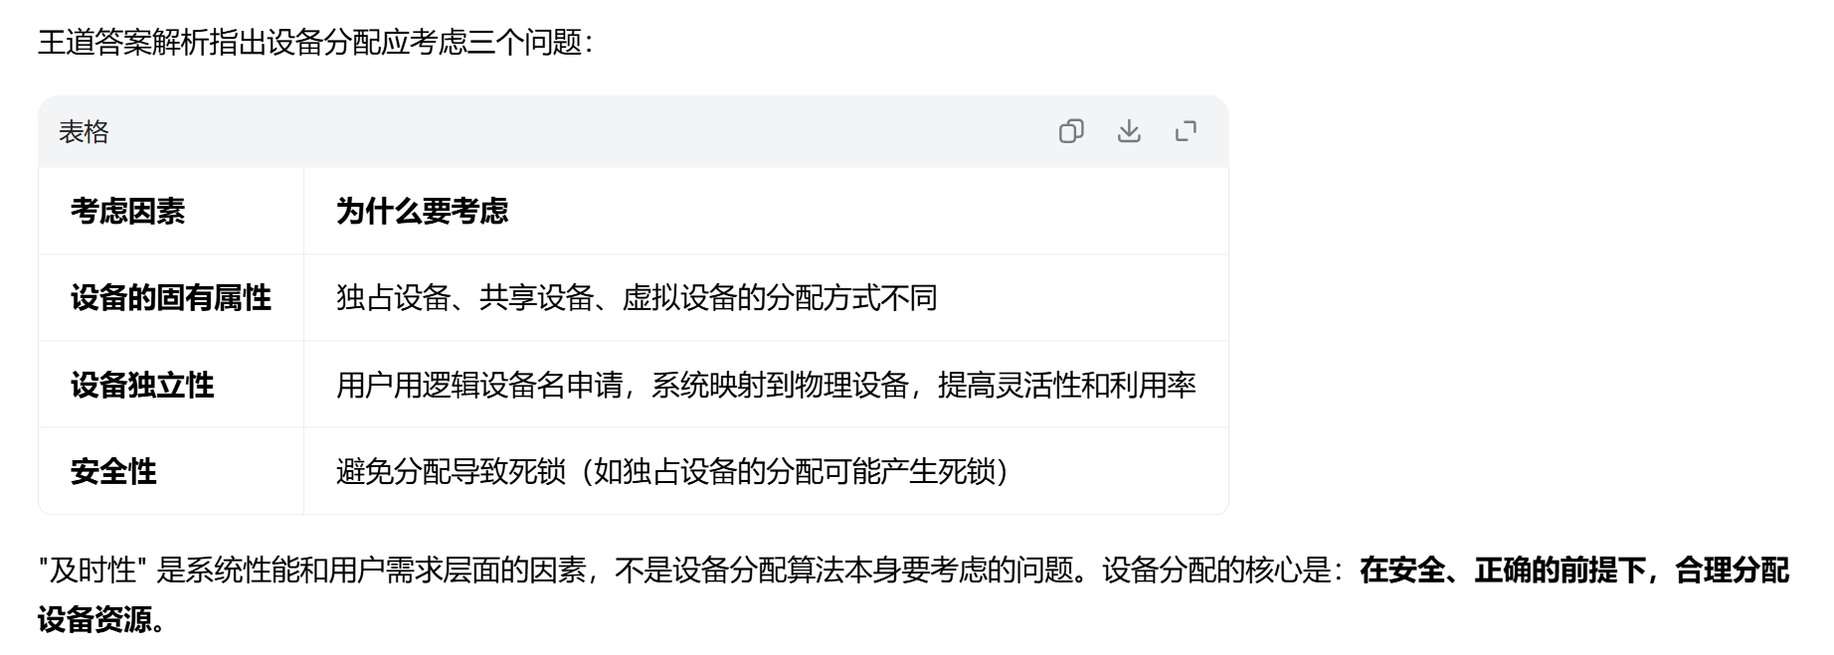

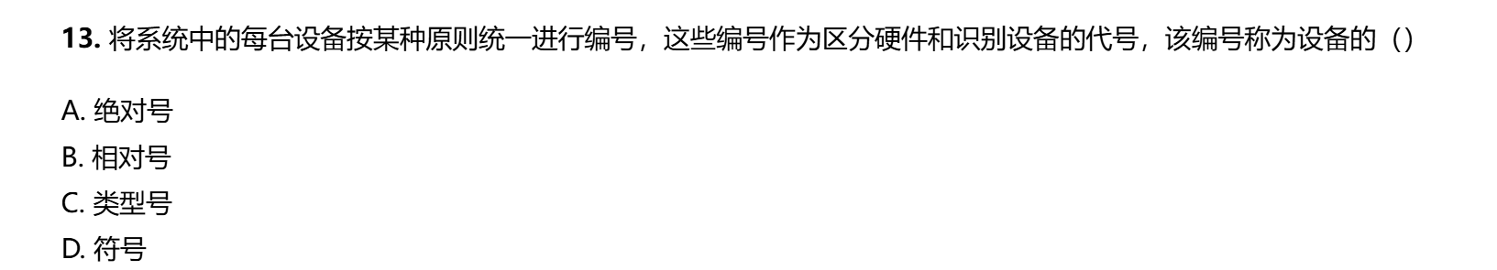
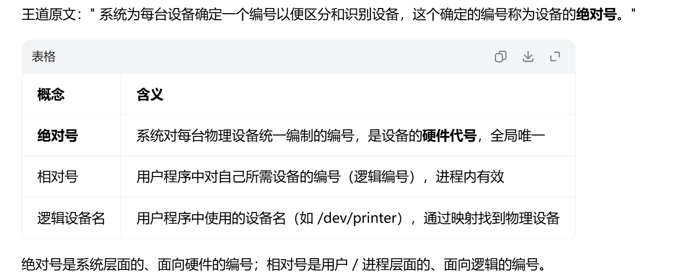

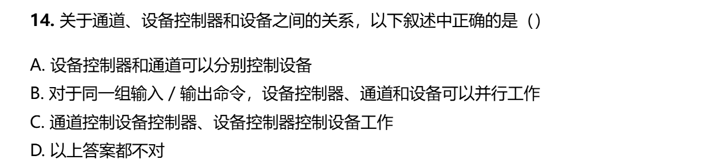
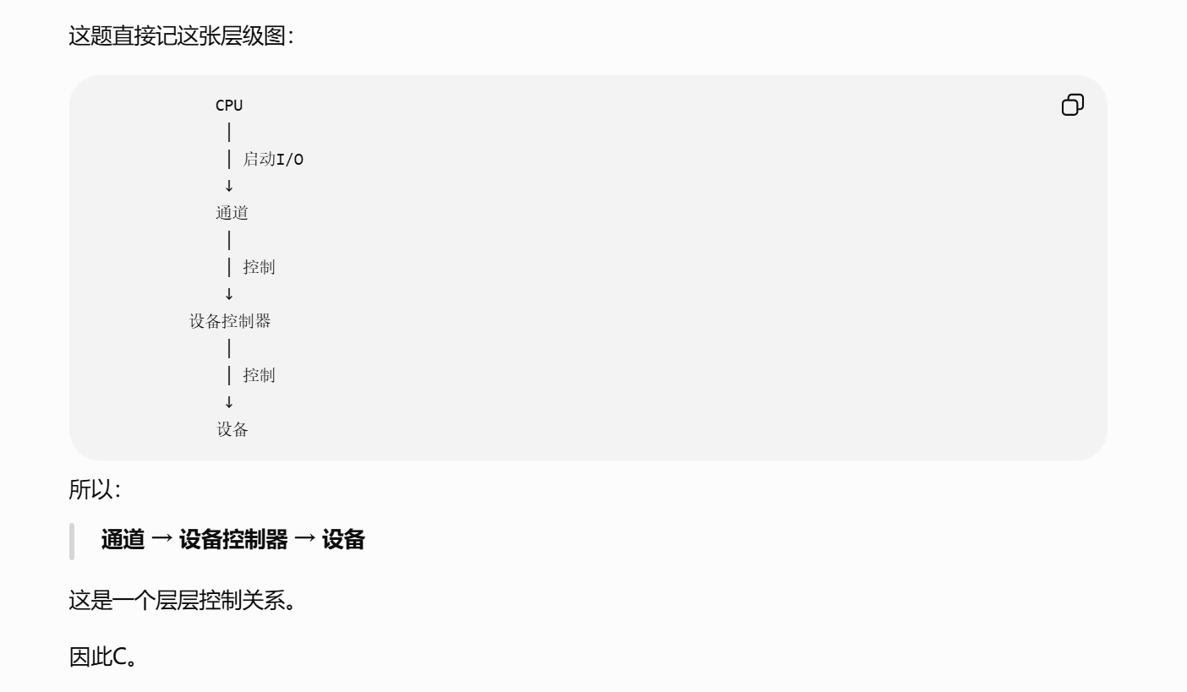
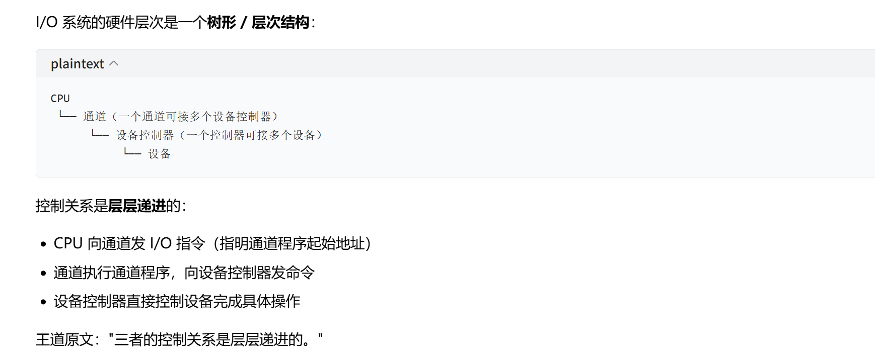
https://chatgpt.com/g/g-p-6a4147b6a8088191bef869eb87bbe5c0-cao-zuo-xi-tong/c/6a8857c4-5f90-83e8-b689-d37b05e1d518
https://www.doubao.com/thread/xgf5s0qbd6OUrHYVq

题2：
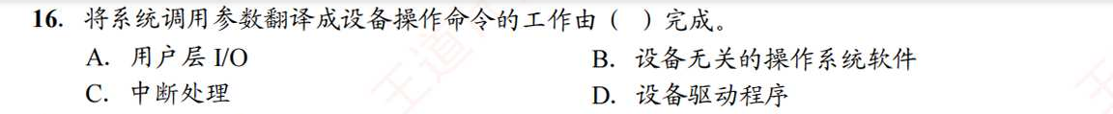
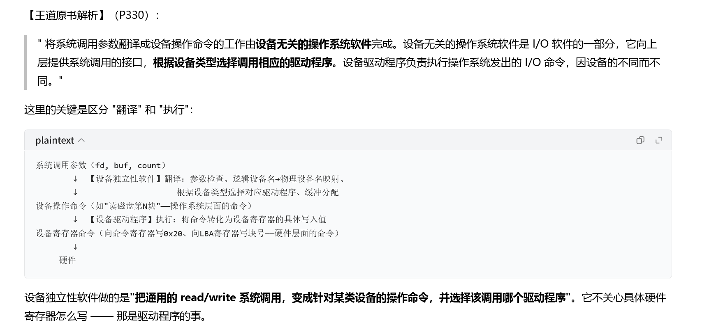
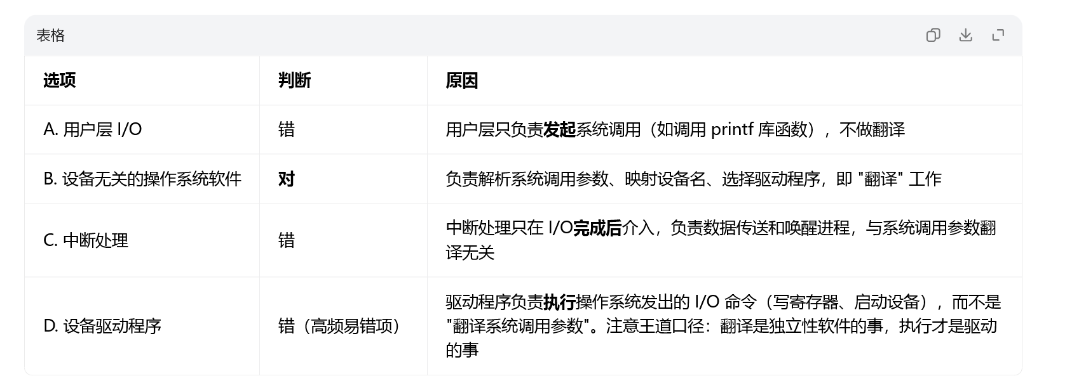


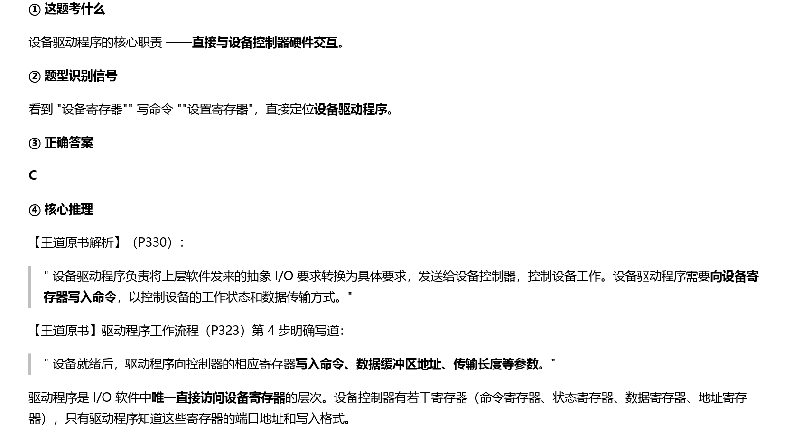
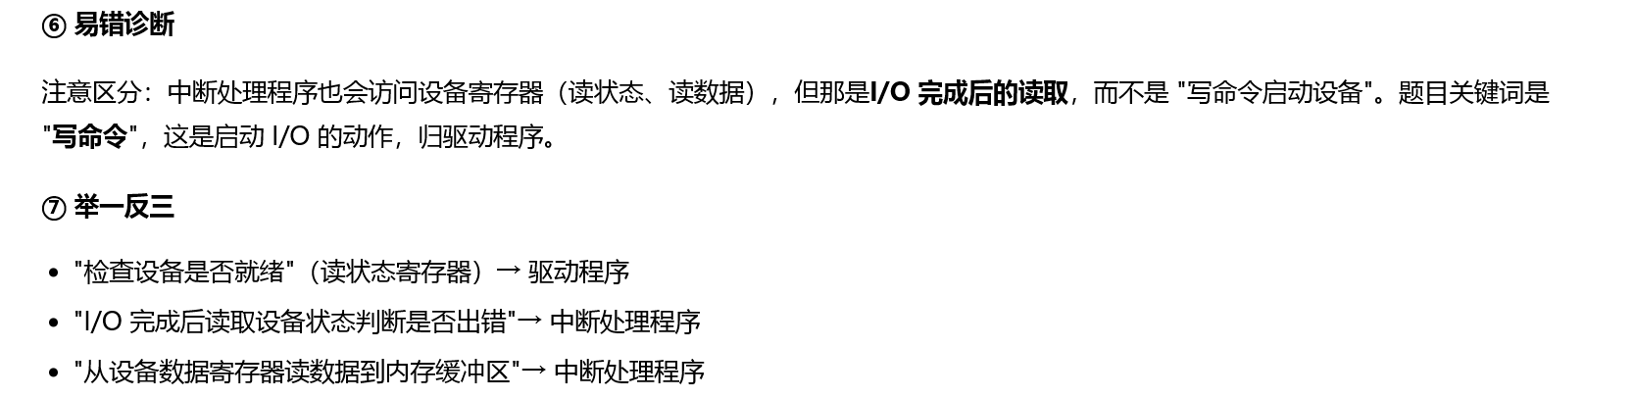

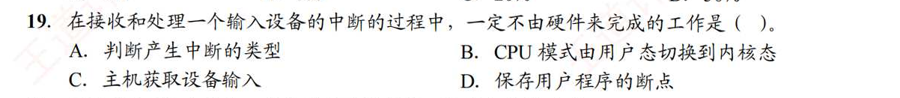
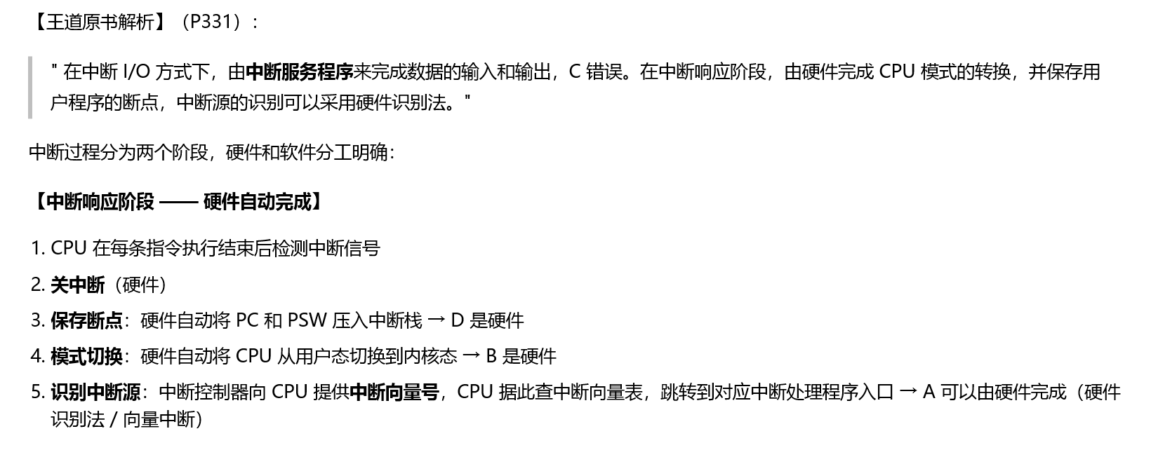
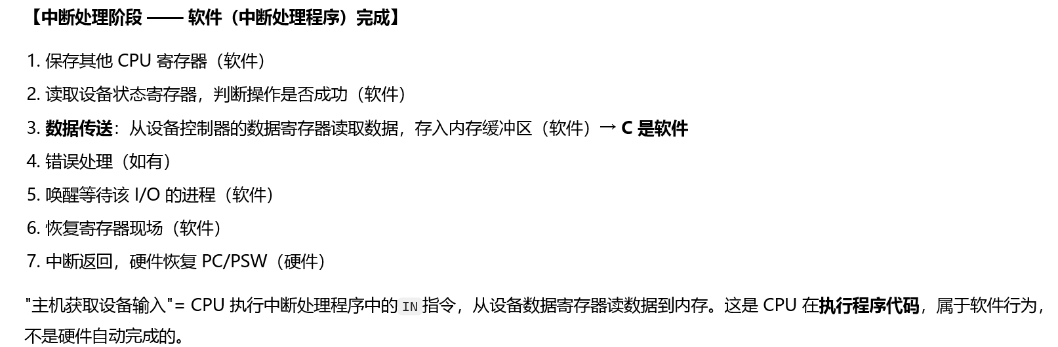
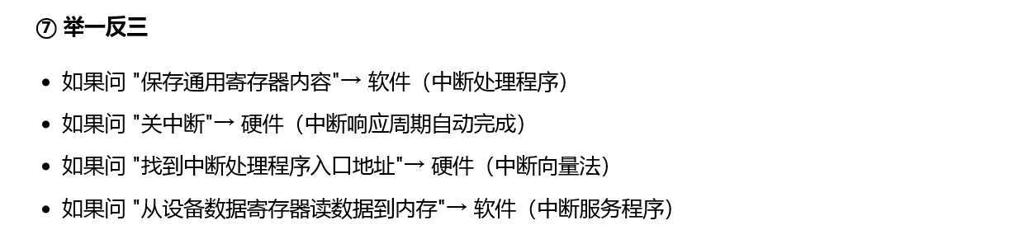

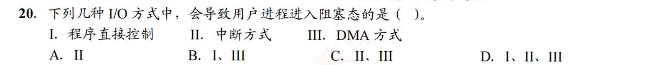
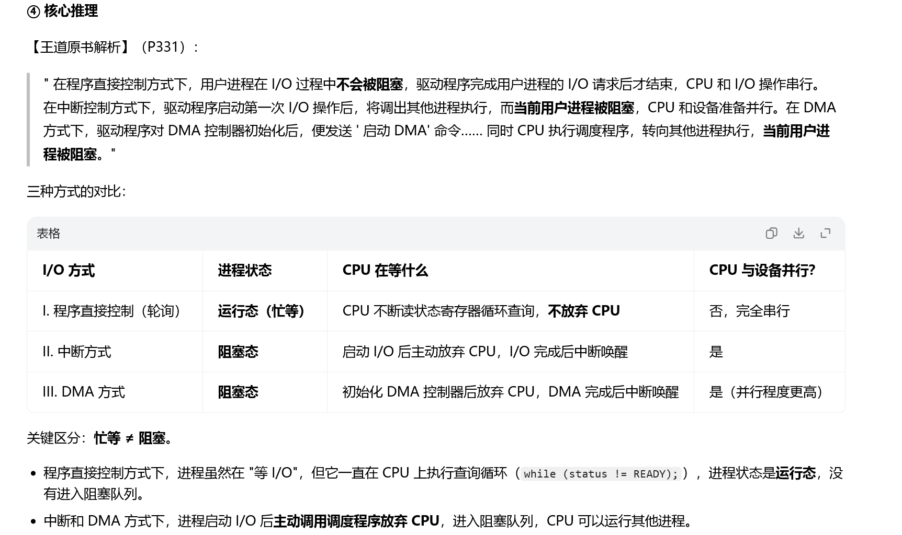
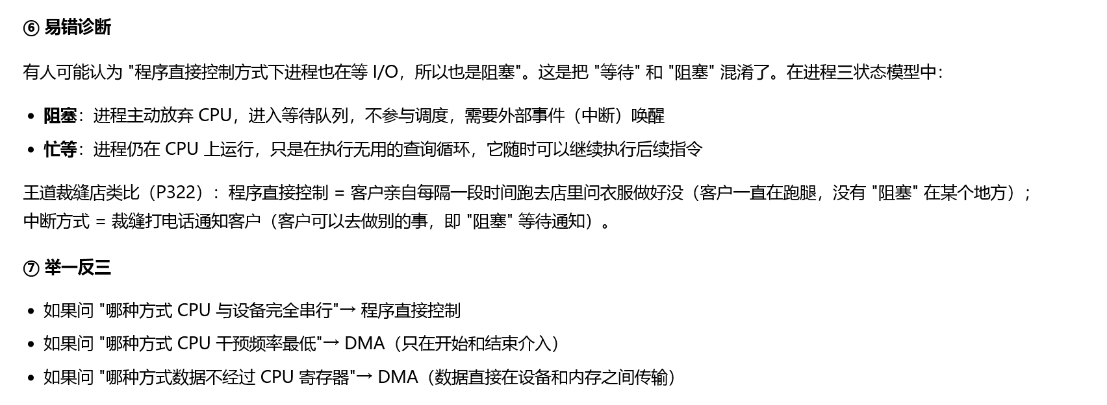

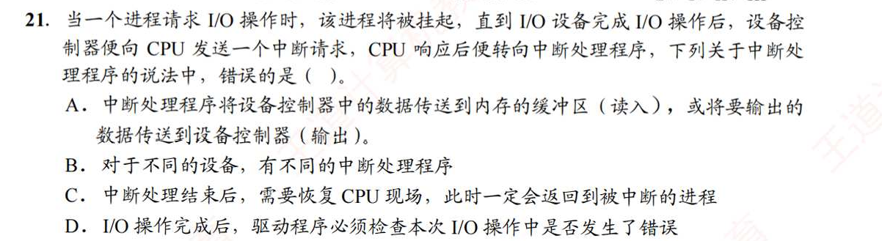
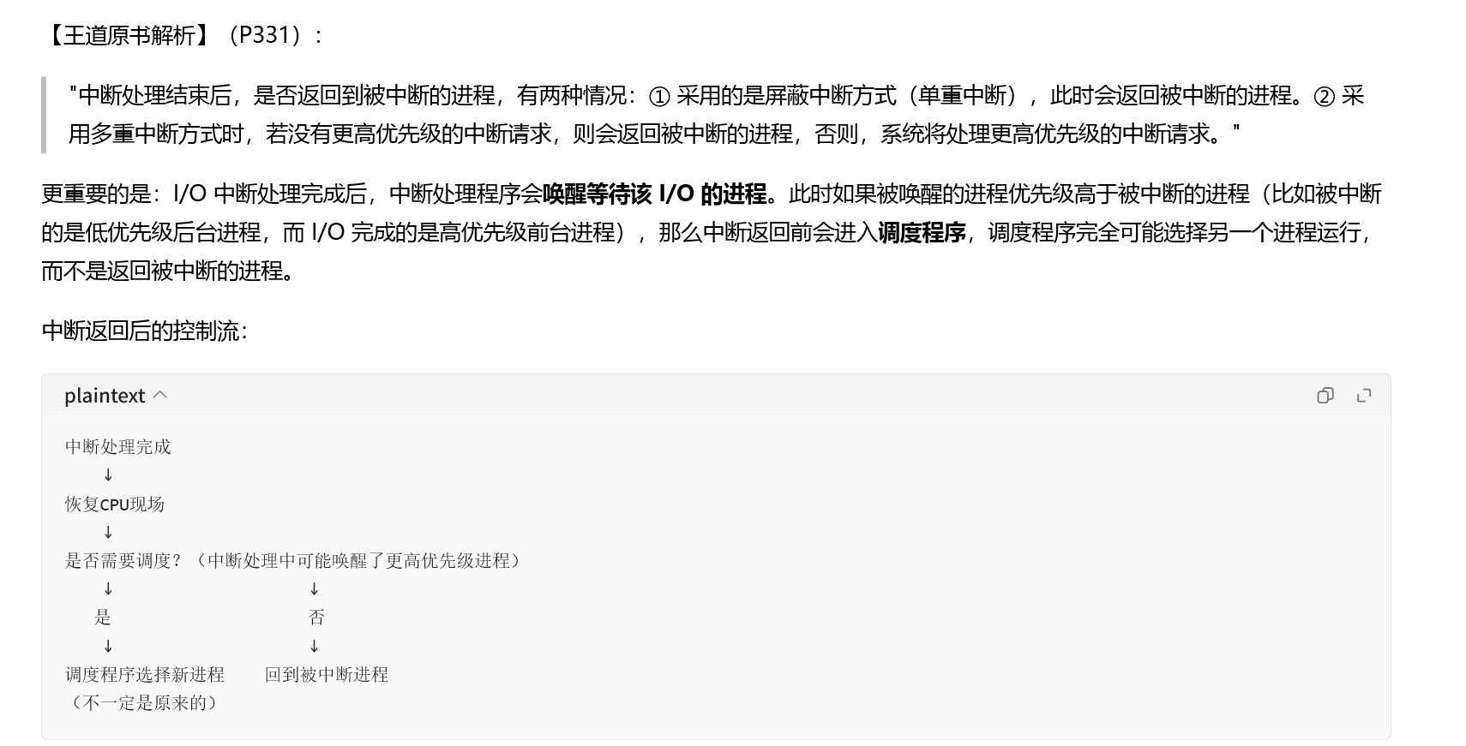
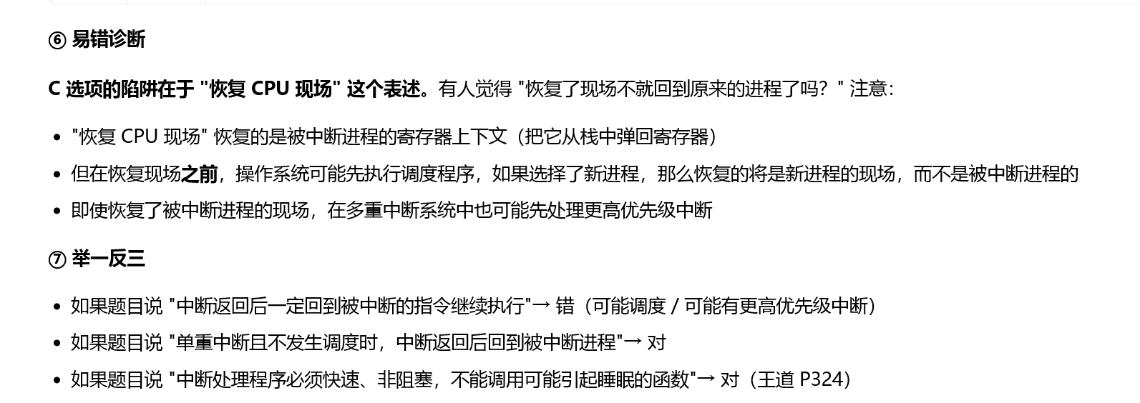

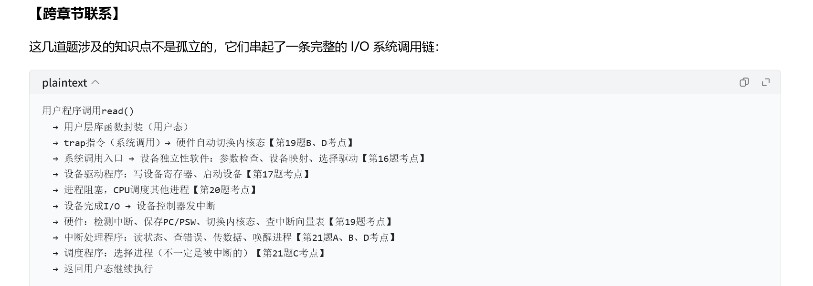
https://chatgpt.com/g/g-p-6a4147b6a8088191bef869eb87bbe5c0-cao-zuo-xi-tong/c/6a894846-65e8-83ee-b7a2-d0c6a0dbe82c

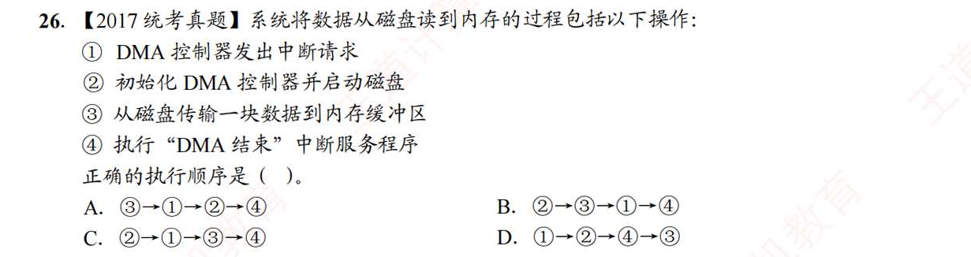
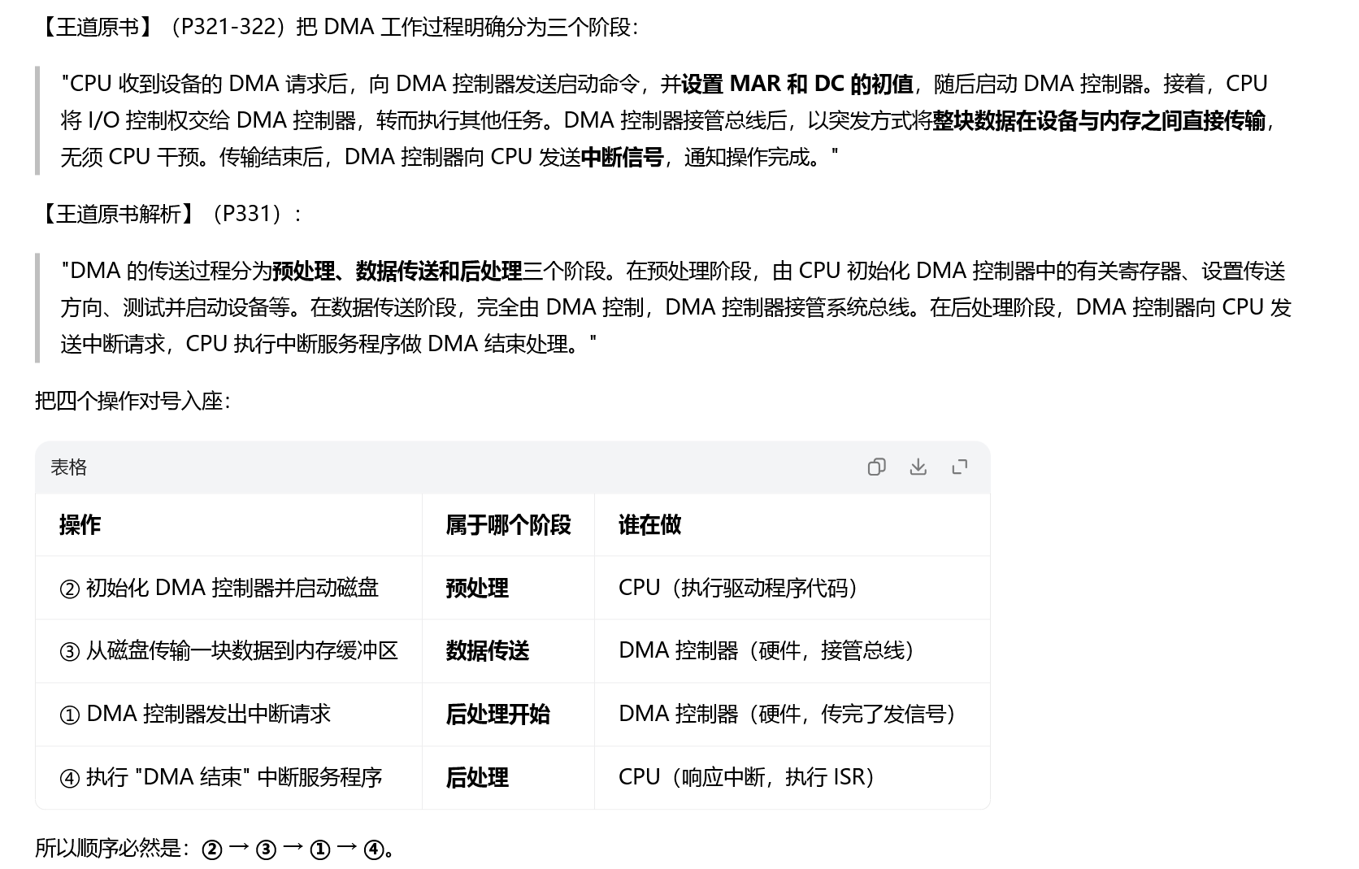
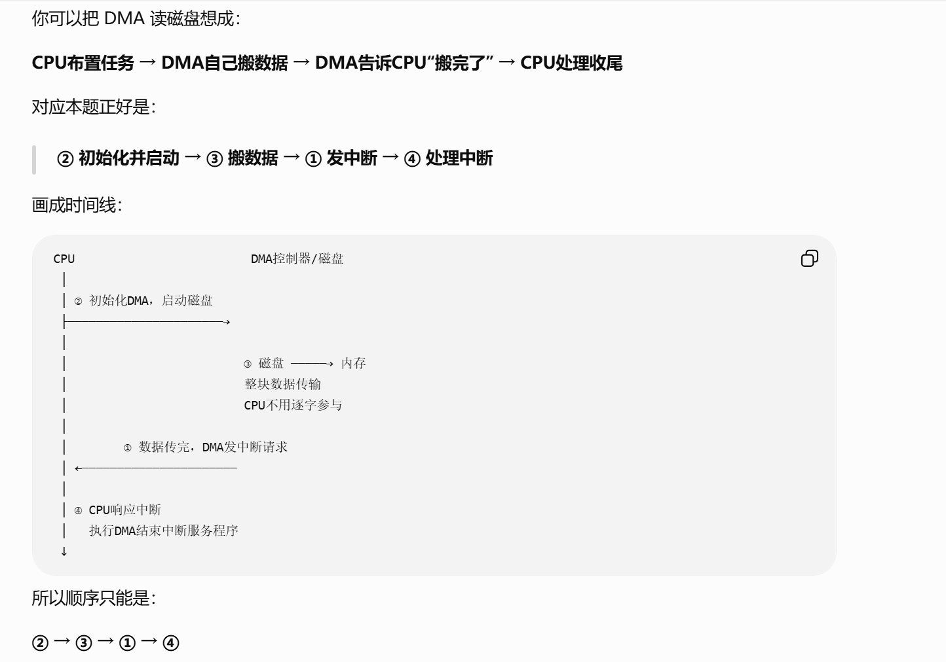
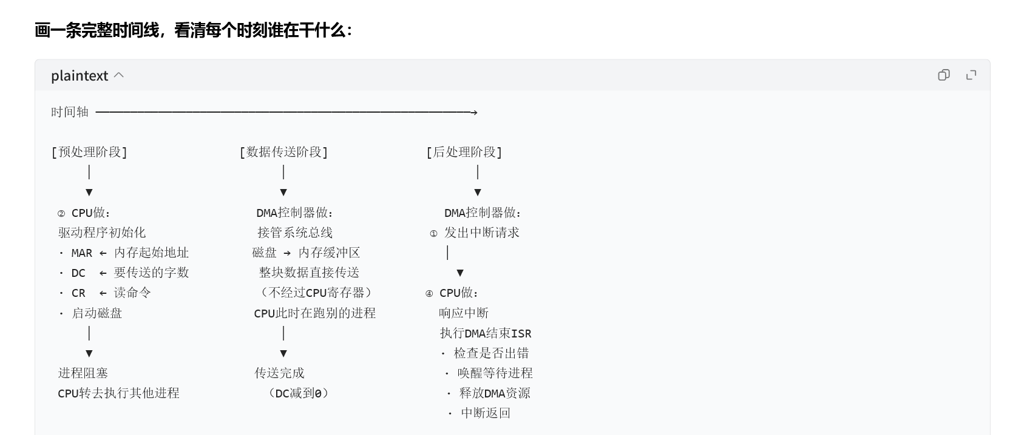
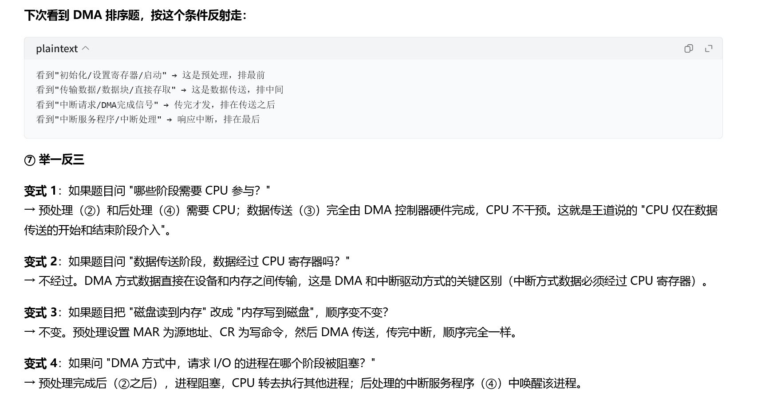
https://www.doubao.com/thread/x5lcHa8UU0eCYkHg7
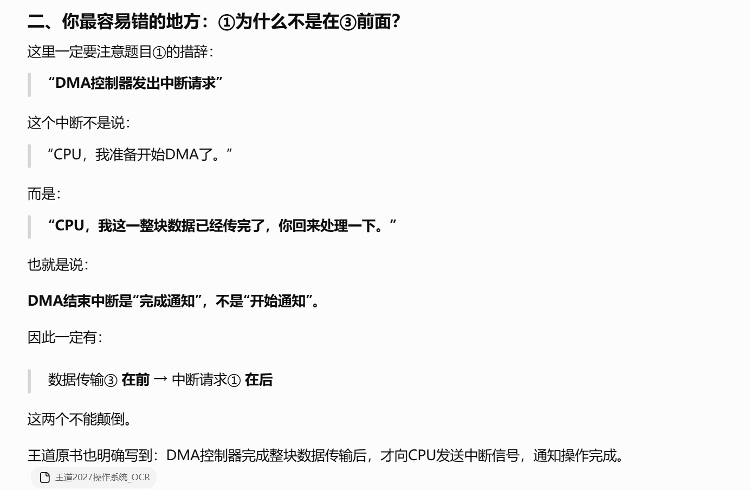
https://chatgpt.com/g/g-p-6a4147b6a8088191bef869eb87bbe5c0-cao-zuo-xi-tong/c/6a8953ed-9288-83ee-889e-5ec1b6f327e9

题3：
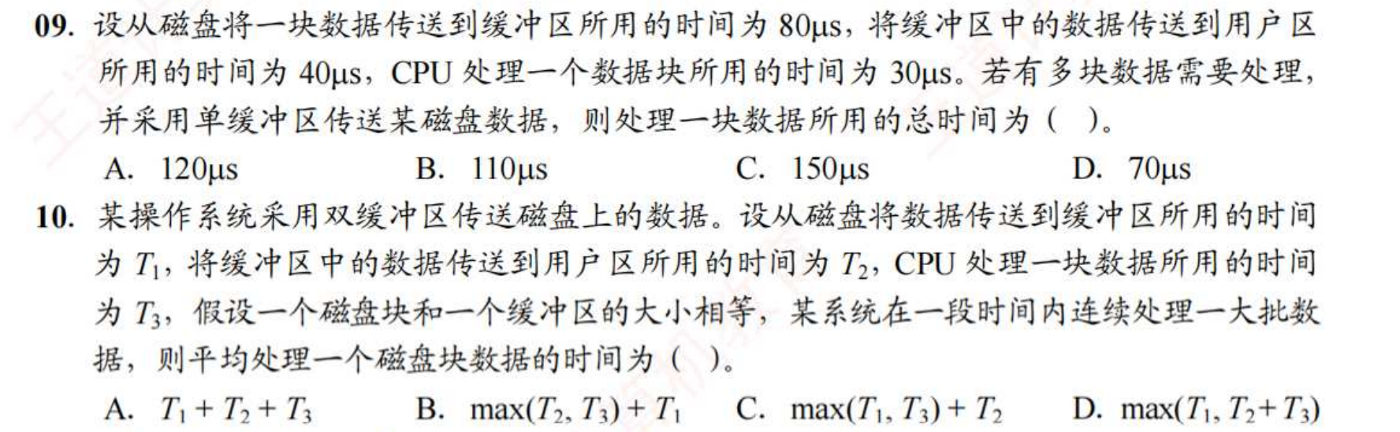
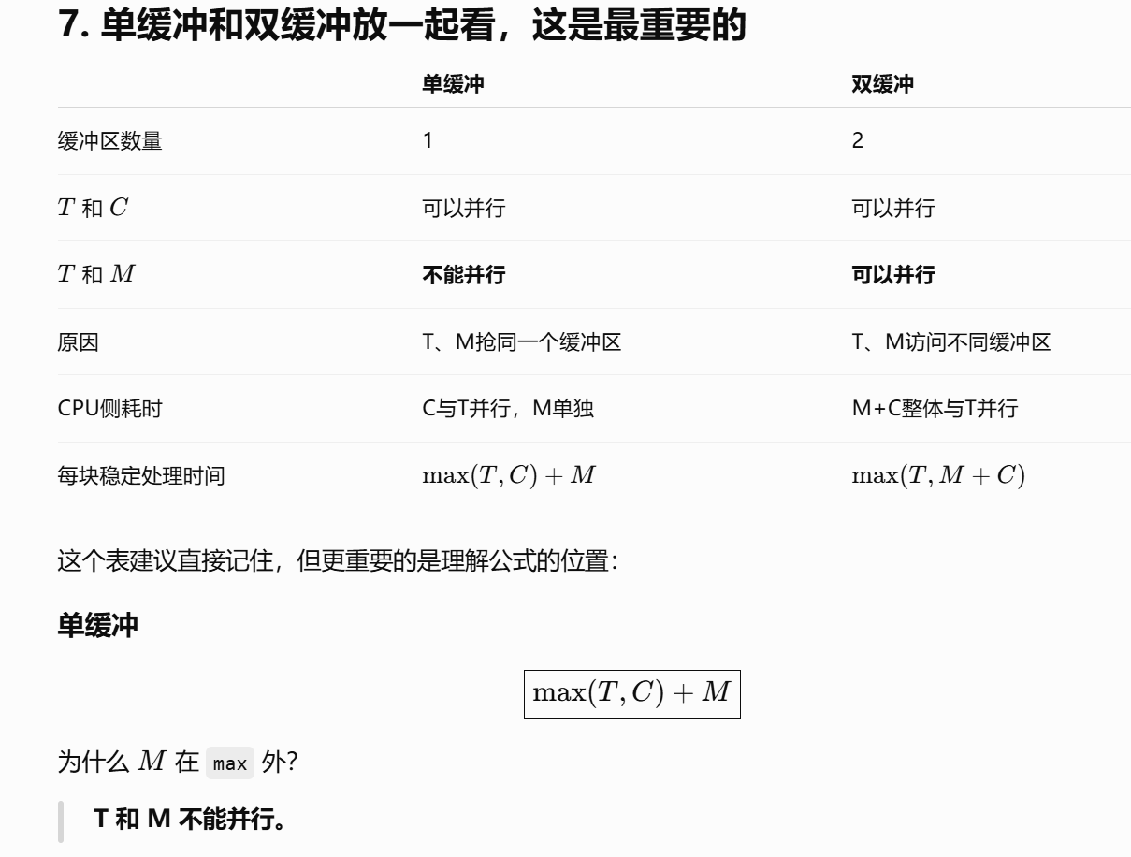
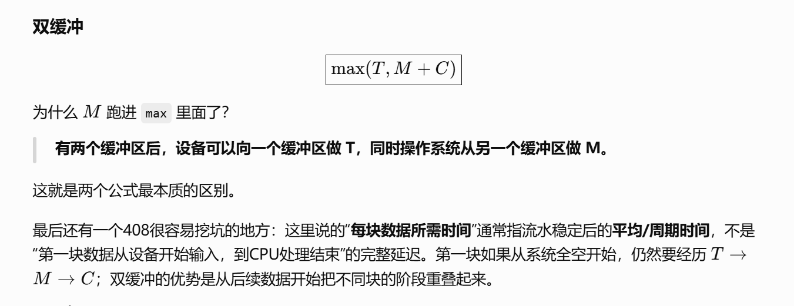

题4：
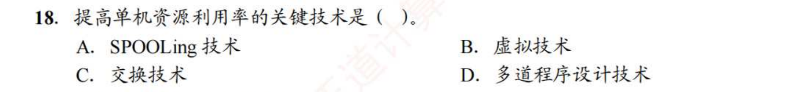
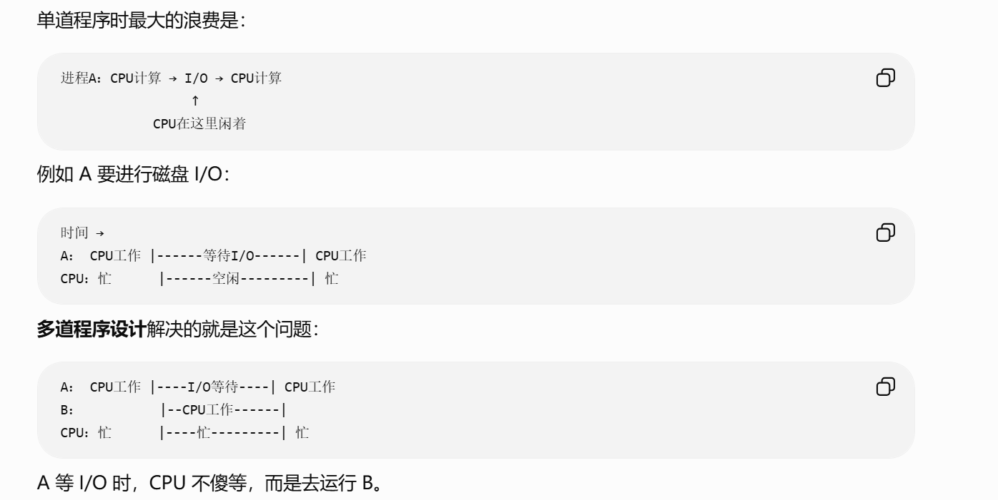
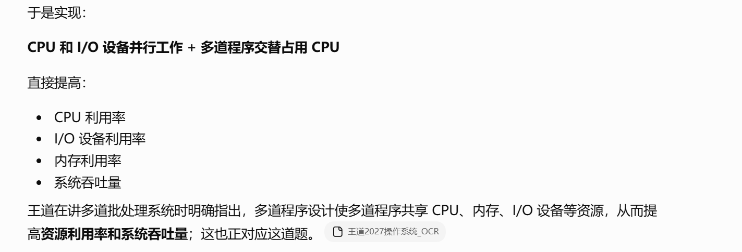
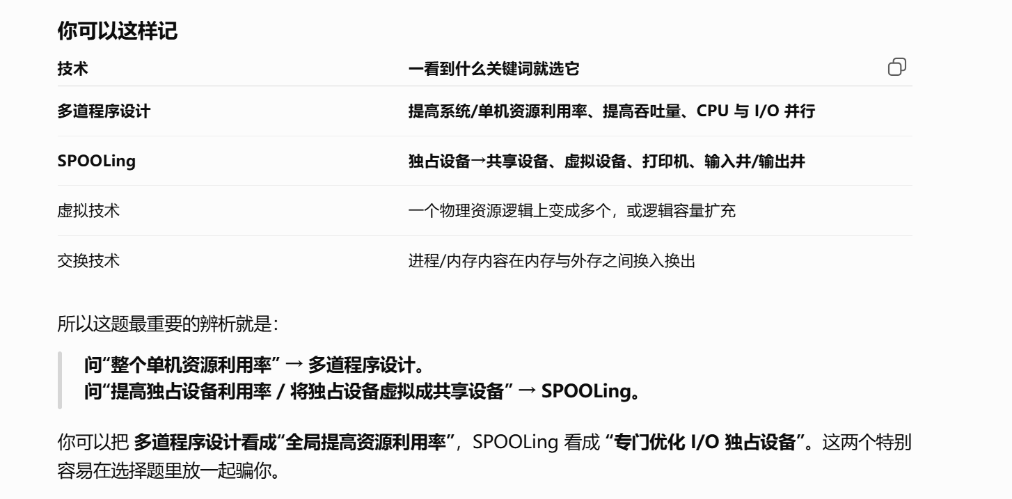
https://chatgpt.com/g/g-p-6a4147b6a8088191bef869eb87bbe5c0-cao-zuo-xi-tong/c/6a8a9c74-e90c-83ee-bac8-816d0b207c10

题5：
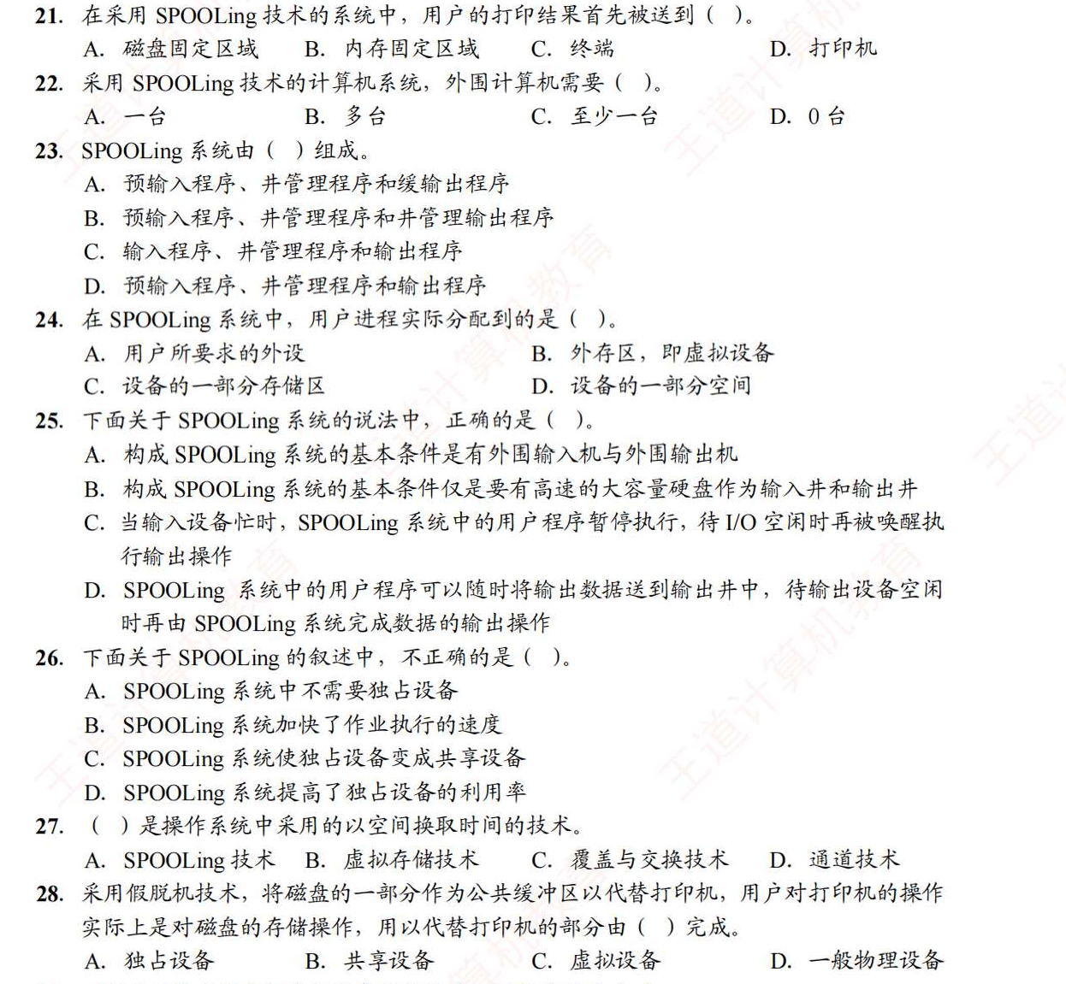
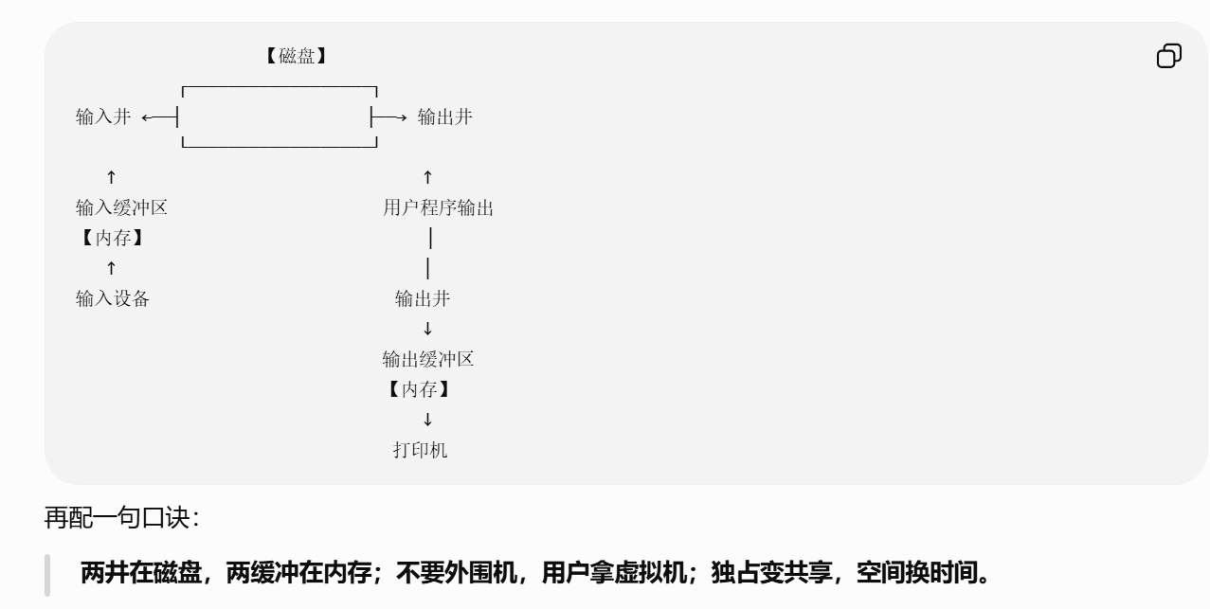
https://chatgpt.com/g/g-p-6a4147b6a8088191bef869eb87bbe5c0-cao-zuo-xi-tong/c/6a8aae26-27f4-83e8-9104-7601a563389f

题6：
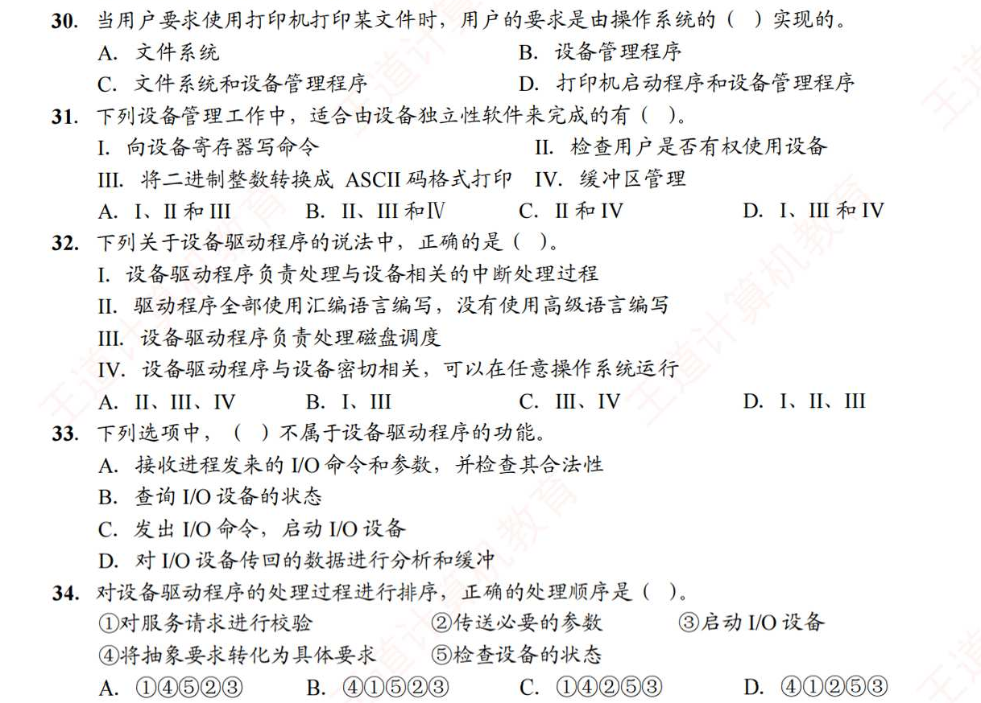
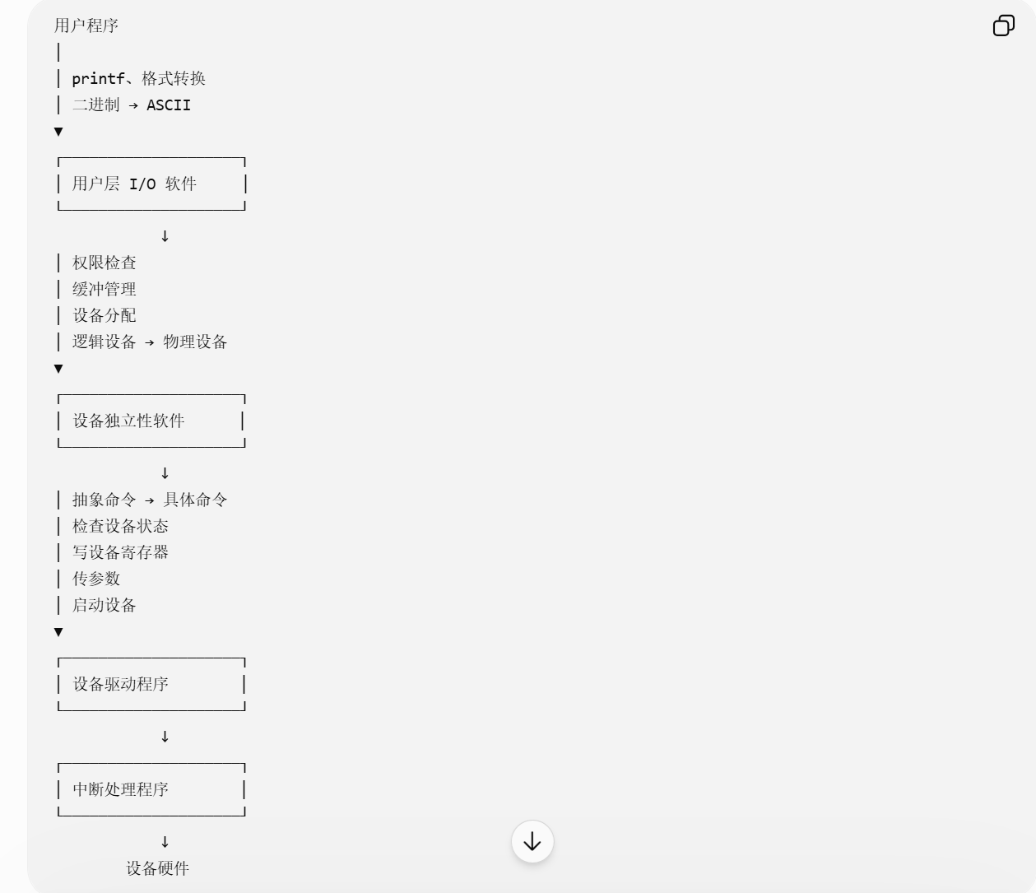
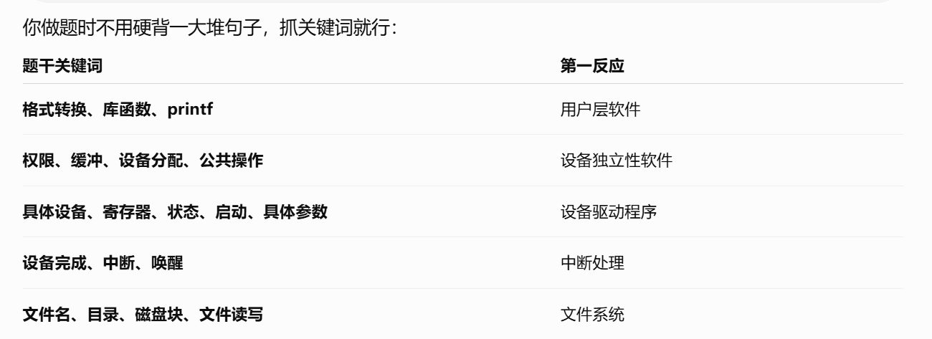
https://chatgpt.com/g/g-p-6a4147b6a8088191bef869eb87bbe5c0-cao-zuo-xi-tong/c/6a8ab378-2550-83ee-8303-af2ad5d32e73

题7：
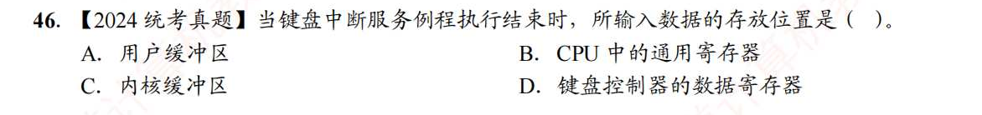
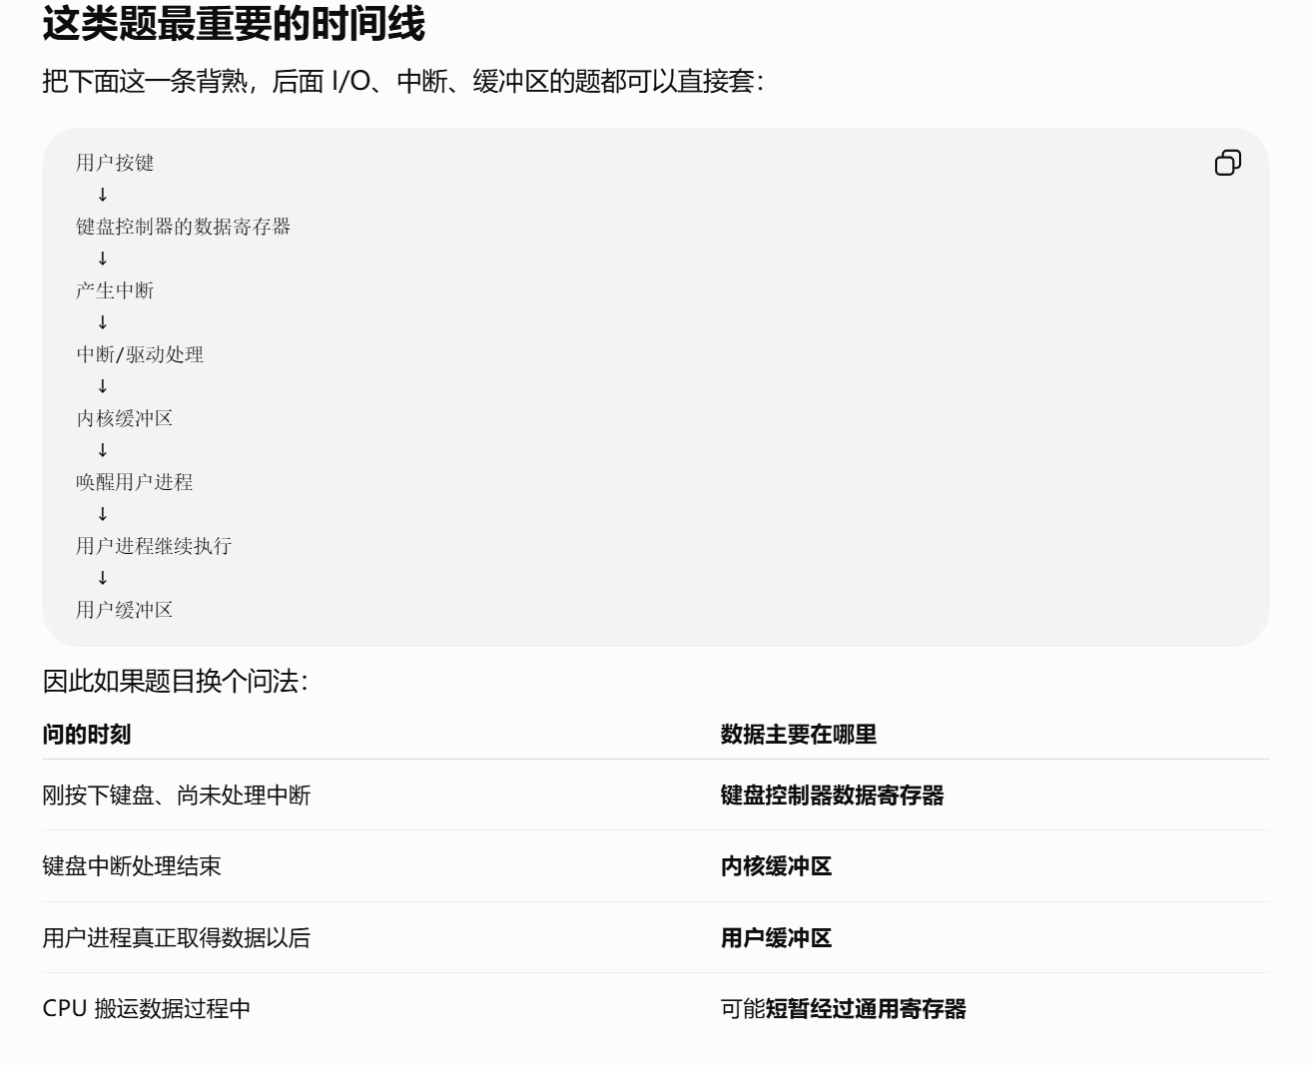
https://chatgpt.com/g/g-p-6a4147b6a8088191bef869eb87bbe5c0-cao-zuo-xi-tong/c/6a8ac73d-e688-83e9-8913-d25f3fdc8bf1
题8：
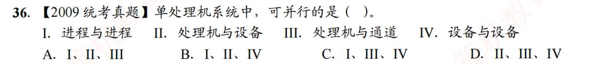
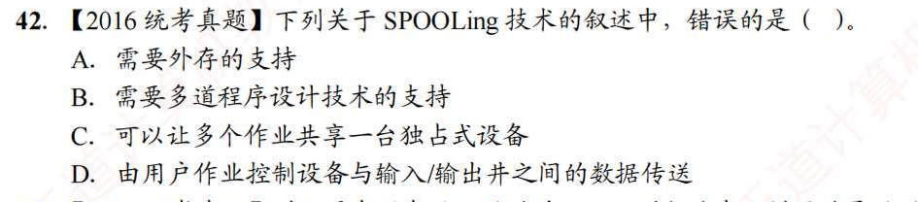
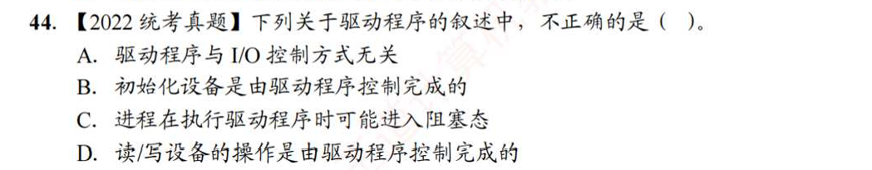
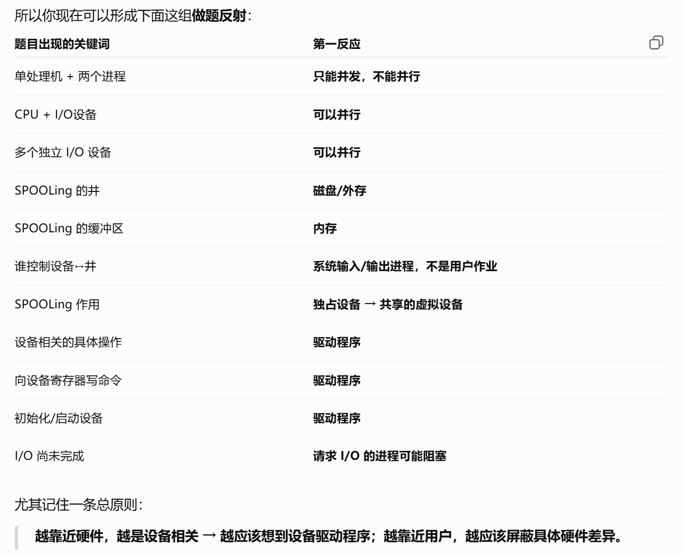
https://chatgpt.com/g/g-p-6a4147b6a8088191bef869eb87bbe5c0-cao-zuo-xi-tong/c/6a8ad2d5-2b48-83e8-827c-d1facabfe6af
|（注：部分内容可能由 AI 生成）

